George J. Reulet

January 18, 1925 – May 16, 2018

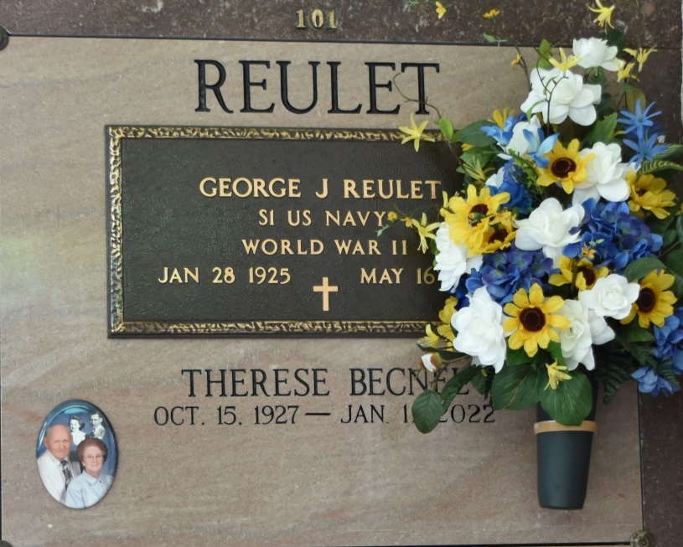

George Reulet, 93, a native and resident of Vacherie, passed away on May 16, 2018. A visitation will be held in his honor on Friday, May 18, at Our Lady of Peace Catholic Church in Vacherie from 8 a.m. until the Mass of Christian Burial at 11 a.m. The burial will follow in Our Lady of Peace Cemetery. He is survived by his wife, Therese B. Reulet; sons, Samuel Jude (Ruth), Dale (Maxine), Merritte (Mary), Martin (Tiffany), Rene and Lynn (Angie) Reulet; daughters, Geneva R. (Tommy) Breaux, Georgine R. (Joey) Fonseca and Meta R. (Mark) Ordoyne; 19 grandchildren; 26 great-grandchildren; seven great-great-grandchildren; and brother, Richard Reulet, Sr. He was preceded in death by his parents, Placide Reulet Sr. and Eve Reulet; brothers, Antoine, Remy, Placide Jr. and Wilson Reulet; and sisters, Olga Becnel, Denise Percle and Rita Toups. Special thanks to Journey Hospice, Deacon Jimmy, Holly, Beverly and personal attendant, Thalia Ordoyne. Thibodaux Funeral Home Inc. is in charge of arrangements.

Houma Today & The Daily Comet, Terrebonne Parish, LA

May 16 to May 17, 2018