Kenneth Paul Reulet

Abt. 1966 – March 7, 2016

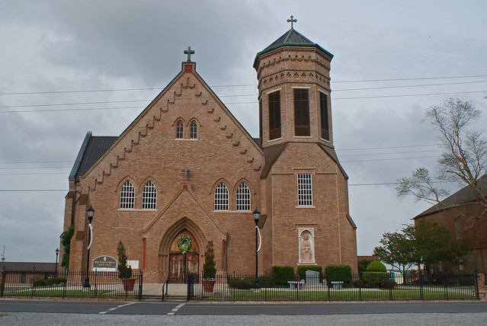

Kenneth Paul Reulet "Stucky", 50, a native and resident of Vacherie passed away on Monday, March 7, 2016, after a courageous battle with cancer.   
 Stucky lived life to the fullest. He loved spending time at the camp with family and friends, music, and dancing. He especially loved spending his days with his wife, children, and grandchildren. He was a member of South Vacherie Volunteer Fire Department for 26 years. He served as President, Vice President, Fire Chief, and was currently serving as Treasurer. He was President of the St. James Parish Fire Association and a member of the St. James Parish Planning Commission.   
 He is survived by his wife, Brenda Dencausse Reulet; one daughter Meah Reulet Badeaux (TJ); three grandchildren, Baylee Alice Badeaux, Timothy "Beaux" Badeaux III, and Brooks Kenneth Badeaux; one son Rylee Reulet; one step-daughter, Meaghan Hendricks Donewar (Ross); one step-son, Airman Steven Hendricks; his mother, Marguerite Belle Reulet; four sisters, Angele Rodrigue (Vernon), Pat Gravois (Blaise), Rachel Rome (Lonny), and Margaret Cortez (Scott); three brothers, David (Cheryl), Michael, and Randy (Juliette); and numerous nieces and nephews.   
 Preceded in death by his father, Lloyd "Bim" Reulet; his grandparents, Lazare and Angele Reulet and Lucien and Angele Steib; and one brother, Lynn J. Reulet.   
 Visitation will be held on Sunday, March 13, 2016 at 5:00 p.m. – 8:00 p.m. at Ourso Funeral Home in Donaldsonville and will resume on Monday, March 14, 2016 at 8:00 a.m. until Funeral Service at 11:00 a.m. at Our Lady of Peace Catholic Church in Vacherie. Interment to follow in church mausoleum. Ourso Funeral Home of Donaldsonville is in charge of arrangements.  
  
Published in TheAdvocate.com from Mar. 10 to Mar. 17, 2016