Lois Marie (Falgoust) Reulet

September 24, 1928 – December 5, 2019

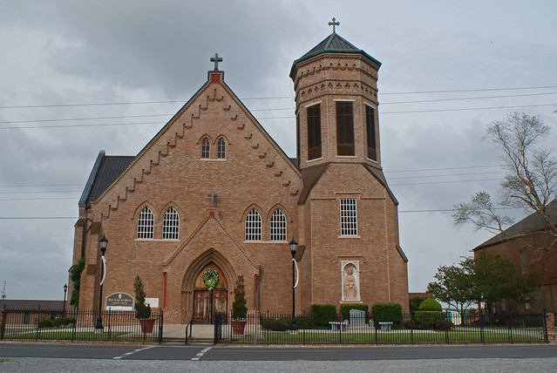

Marie Lois Reulet, 91, a native and resident of Vacherie, LA passed away on Thursday, December 5, 2019.

Visitation will be held on Saturday, December 7, 2019 at Our Lady of Peace Catholic Church in Vacherie, LA from 8am until Mass of Christian Burial at 11am officiated by Fr. Matthew McCaughey. Interment to follow in the church Mausoleum.

Lois is survived by her seven children, Sheila (Francis “Butsy”) Becnel, Pam (Wayne “Green”) Kliebert, Arlene (Wendell “Duke”) Ockmond, Myron (Anne) Reulet, Rachel (Perry) Perque, Lola Mahler, Tammie (Mark “Pott”) Aubert; daughter-in-law, JoAnn Reulet; 15 grandchildren; 20 great grandchildren; one brother, Daniel (Alice) Falgoust; three sisters, Lydia F. Granier, Virgia F. Cortez and Vivian F. Thibodaux.

She is preceded in death by her parents, Garfield and Genevieve Webre Falgoust; husband, Pierre H. Reulet; one son, Kirk Peter Reulet; one grandson, Matthew Joseph Mahler; one great grandson, Drake Michael Kliebert, one son-in-law, Boyd Anthony Mahler and two brothers, Antoine B. Falgoust and Ellis C. Falgoust.

In lieu of flowers, memorial donations can be sent to St. James Arc at 29150 Health Unit Street Vacherie, LA.

Ourso Funeral Home, Donaldsonville, LA