Lynn Jude Reulet

March 8, 1961 – November 29, 2014

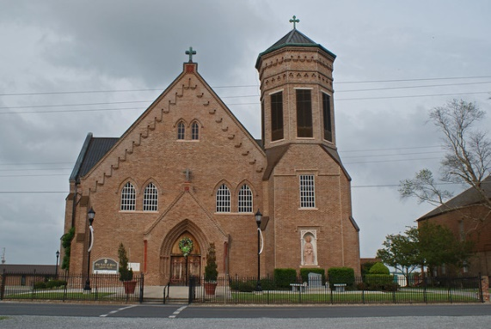

Lynn Jude Reulet, 53, entered eternal life Saturday, Nov. 29, 2014, after a five year battle with cancer.  
 Visitation will be from 8 a.m. until funeral time Wednesday at Our Lady of Peace Catholic Church in Vacherie. The Rosary will be recited at 9:30 a.m. Wednesday at the church by the Knights of Columbus. A Mass of Christian burial will be at 11 a.m. Wednesday at the church officiate by Father Michael Miceli, with burial in the church cemetery.  
 He is survived by his children, Corey, Chris, Cassie, Caitie, and Caroline Reulet; mother, Margaret Belle Reulet; sisters, Angele Rodrigue (Vernon), Pat Gravois (Blaise), Rachel Rome (Lonny "Monkey"), and Margaret Cortez (Scott "Chico"); brothers, David "Bim" (Cheryl), Michael "Peabody", Randy (Juliette), and Kenneth "Stucky" (Brenda); and numerous nieces, nephews, and other relatives.  
 He was preceded in death by his Father, Lloyd "Bim" Reulet; and grandparents, Lazare and Angele Reulet and Lucien and Angele Steib.  
 Lynn worked for CAMTURA, then for FABCO as a production superintendent. He served as a past grand knight for Knights of Columbus Council No. 11857, served as President and Fire Chief for the South Vacherie Volunteer Fire Department, and served as Chairman of the Building Committee for Our Lady of Peace Church. Lynn devoted his life to volunteering for his community and school activities for his children. He loved to fish, hunt, and cook, especially for his family gatherings.  
 Special thanks to the entire community for their prayers, volunteers helping to cook meals for his family, his drivers for bringing him to doctors' appointments, different prayer groups for dedicating their prayers to his needs, to his traveling group who on occasion brought him to sight see around the state, and to the doctors and staff of Tulane and Thibodaux Cancer Centers.  
 In lieu of flowers, donations may be made in Lynn's memory to Our Lady of Peace Church Capital Campaign, or the St. James Parish Cancer Relay For Life Campaign. To offer condolences to the family please visit [www.oursodonaldsonville.com](http://www.oursodonaldsonville.com). Ourso Funeral Home in Gonzales is in charge of arrangements.

Unknown source