Michael Joseph Reulet

February 16, 1958 – November 13, 2016

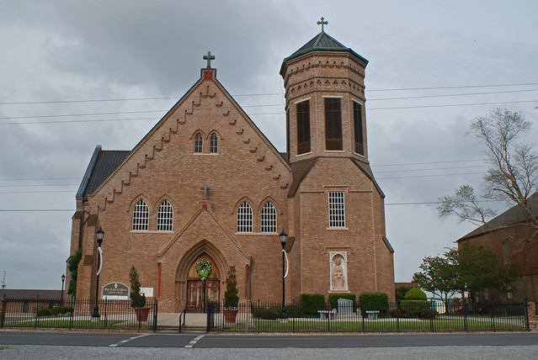

Michael Joseph “Peabody” Reulet, 58, entered eternal life on November 13, 2016 after a year long courageous battle with cancer. Michael is survived by his mother, Belle Reulet; his sisters, Angele Rodrigue(Vernon), Patricia Gravois (Blaise), Rachel Rome (Lonny), and Margaret Cortez (Scott); and his brothers, David “Bim” and Randy Reulet(Juliette), as well as numerous nieces, nephews and friends.   
  
Michael was preceded in death by his father, Lloyd “Bim” Reulet, his brothers Lynn and Kenneth “Stucky”Reulet and sister-in-law Cheryl Marse Reulet.   
  
Funeral services will be held on Wednesday, November 16, 2016 at Our Lady of Peace Catholic Church in Vacherie, LA at 11:00 a.m.   
  
Visitation in his honor will be held from 9:00 a.m. to funeral time. Interment will be in the church cemetery.   
  
ROSE LYNN FUNERAL SERVICES, 1870 Cabanose Ave., Lutcher, LA is in charge of the arrangements.   
  
Published online by Rose Lynn Funeral Home, Lutcher, Louisiana