Noelie Marie (Rome) Reulet

May 5, 1905 – December 27, 1993

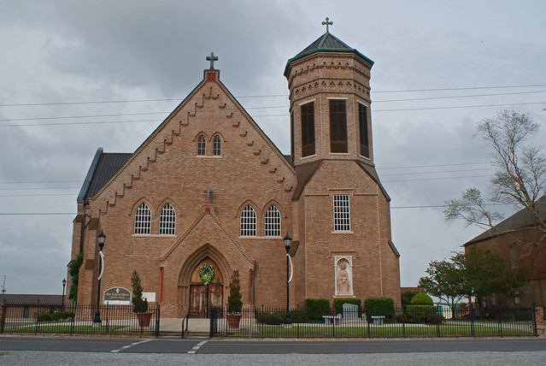

A Mass of Christian burial will be celebrated at 10 a.m. Wednesday at Our Lady of Peach Catholic Church in Vacherie for Noelie Rome Reulet, 88, a native and resident of Vacherie, who died at 10 a.m. Monday, Dec. 27.

A religious service is scheduled for 9:45 a.m. Wednesday at the church. Visitation will be 5 to 10 p.m. today and 8 a.m. to funeral time Wednesday at the church. Burial will be in the church cemetery.

She was the mother of Pierre Irvin Reulet; sister of Josephine Keller and Uranie Pizzuto. She is also survived by two grandchildren and a great-grandchild. She was preceded in death by her husband, Pierre Reulet; parents, Roselus and Julia Simon Rome; three sisters, Lucille Rome, Julie Folse and Marie Ducote; and six brothers, Amelus, Frozin, Lucien, Ferdinand, Etienne and Joseph Rome.

Thibodaux Funeral Home is in charge of arrangements.

Unknown source

Contributed by Veronica Sampey