Lucille M. (Dumas) Riley

September 13, 1921 – September 4, 2018

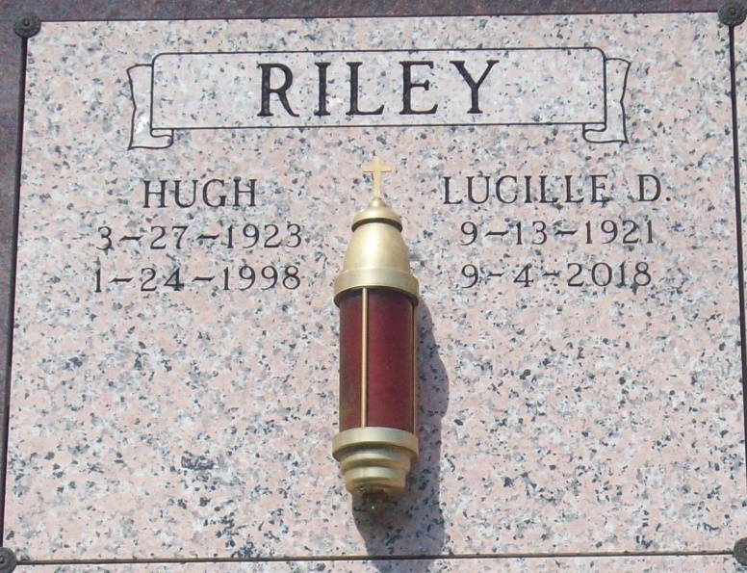

Photo by TMB

Lucille M. Riley departed this life on Tuesday, September 4, 2018, at the age of 96. Daughter of the late Pierre Eliszy Dumas and Gracieuse Jones Dumas. Wife of the late Hugh Walter Riley. Sister of Paul Joseph Dumas (Mary) of New Orleans, LA, and the late Eastern Sr., Eliszy Sr., Herman Sr., Victor Dumas (Gracie Mae), Grace D. Gros, Marie Elizabeth D. Harry, Gladys D. Trepagnier and Margaret D. Robinson (Samuel Robinson Sr.). She is survived by a host of nieces, nephews and cousins. Relatives and friends of the family, also priest and parishioners of Our Lady of Peace Catholic Church and Mater Dolorosa Catholic Church, also employees and members of Kinship Senior Center are invited to attend a Visitation on Wednesday, September 12, 2018 at D.W. Rhodes Chapel, 3933 Washington Ave., from 3:00 to 5:00 pm. A Funeral Mass of Christian Burial will be held at Our Lady of Peace Catholic Church, 13281 Hwy. 644 Vacherie, LA, on Thursday, September 13, 2018 at 11:00 am. Visitation begins at 9:00 am. Interment: Our Lady of Peace Catholic Church Cemetery. Arrangements by D.W. Rhodes Funeral Home. Please visit [www.rhodesfuneral.com](http://www.rhodesfuneral.com/) to sign the online guestbook.

https://obits.nola.com/obituaries/