Allen J. Rodrigue

June 13, 1964 – August 8, 2018

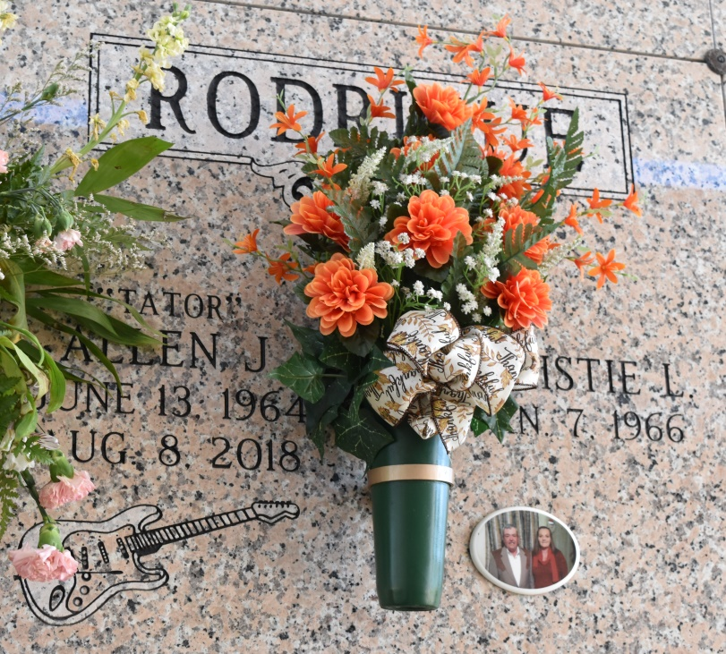

Allen Rodrigue, 54, a native and resident of Vacherie passed away August 8, 2018.  
 A visitation will be held in his honor from 9 a.m. until the Mass of Christian Burial at 11 a.m. Saturday, August 11 at Our Lady of Peace Church in Vacherie. The burial will follow in the church cemetery.  
 He is survived by his wife, Christie Loupe Rodrigue; father, Mack Rodrigue Sr.; sons, Ryan Paul Rodrigue, Dustin Allen Rodrigue and Collin Joseph Rodrigue; brother, Mack Rodrigue Jr.; sister, Penny Navarre; and godchildren, Colby and Tiffany.  
 He was preceded in death by his mother, Alma Arceneaux Rodrigue.  
 He was a loving husband and father, an awesome friend and a great musician.   
 Landry's Funeral Home Inc. is in charge of arrangements.

Published in Houma Today & The Daily Comet, Terrebonne Parish, LA, from Aug. 9 to Aug. 10, 2018