Alwin G. Rodrigue

February 6, 1934 – June 21, 2017

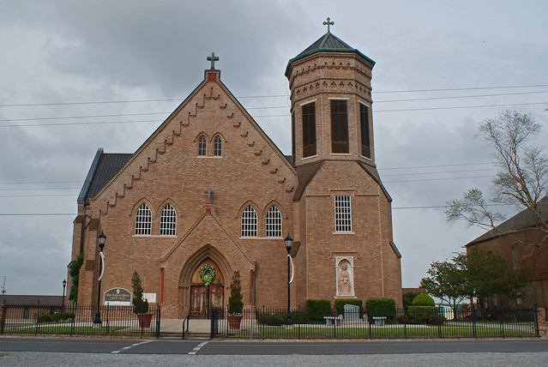

Alwin G. "Red" Rodrigue died on Wednesday, June 21, 2017, at Thibodaux Regional Medical Center. He left behind his wife of 63 years Amazelie (Mazelle) Amedee Rodrigue; four daughters, Carol Ann (Glenn) Hymel, Ellen (Tony) Aucoin, Mary Gravois (Trevor Simon), and Jaime (Troy) Chenier all of Vacherie; and one son, Victor (Paige) Rodrigue of Groves, Texas.   
 Alwin was the proud grandfather of 12 grandchildren and 21 great-grandchildren. He was the brother of Errol Rodrigue, Janet Moates, Sheila Haydel and Charlene Hutchings.   
 He was preceded in death by his parents, Victor and Mae Belle Guidry Rodrigue; sister, Betty Falgoust; two brothers, Edward and Robley Rodrigue; one son-in-law, Spencer Toomer; and one brother-in-law, Alvin Haydel.   
 Alwin was a native and resident of Vacherie for 83 years. He was a member of the National Guard and retired from Kaiser Aluminum after 37 years of employment.   
 Wake will be held on Saturday, June 24, from 8 a.m. to 11:30 a.m. followed by the funeral at 11:30 a.m. at St. Phillip Catholic Church in Vacherie. Interment will follow at Our Lady of Peace mausoleum. Thibodaux Funeral Home Inc. is in charge of arrangements.

Published in Houma Today & The Daily Comet, Terrebonne Parish, LA, from June 21 to June 22, 2017