Cyril Paul Rodrigue

December 1, 1969 – July 20, 2005

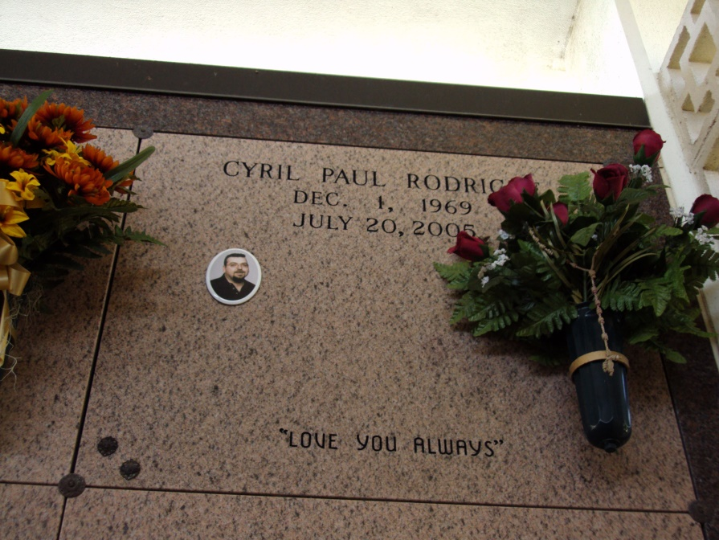

Photo by rrcar

An employee of Chemco Industries of Thibodaux, he was entrusted to God's loving care on Wednesday, July 20, 2005, in Thibodaux. He was 35 and a resident and native of Vacherie.

Visiting at Our Lady of Peace Catholic Church, Vacherie, on Friday, July 22, from 8:45 a.m. until Mass of Christian Burial at noon, with the Rev. Michael Miceli, celebrant. Entombment in the church mausoleum.

He is survived by his parents, Leslie Rodrigue and Antoinette Kliebert Rodrigue of Vacherie; son, Brandon Rodrigue, Thibodaux; daughter, Fallon Rodrigue, Thibodaux; fianceé, Rebecca "Becky" Tabor, and her children, Salena and Clay Tabor, all of Chackbay; two sisters and brothers-in-law, Reasa Lassere and husband Desmond, and Antoinette "Toni" Rodrigue and fiancé Wayne Polkey, all of Vacherie; two godchildren, his nephew, Shelby Lassere, and his niece, Drue Polkey; niece, Hailey Lassere, Vacherie; and the mother of his children, Ashley Hebert, Thibodaux.

He was preceded in death by his paternal grandparents, Max Rodrigue and Earline Simon Rodrigue; maternal grandparents, Cyrille Kliebert and Antoinette Becnel Kliebert and Pamphile Webre and Marie Anna Becnel.

Ourso Funeral Home, Donaldsonville, is in charge of arrangements.

The Advocate, Baton Rouge, LA

July 21, 2005