Simon Peter Rodrigue

April 20, 1931 – December 8, 2008

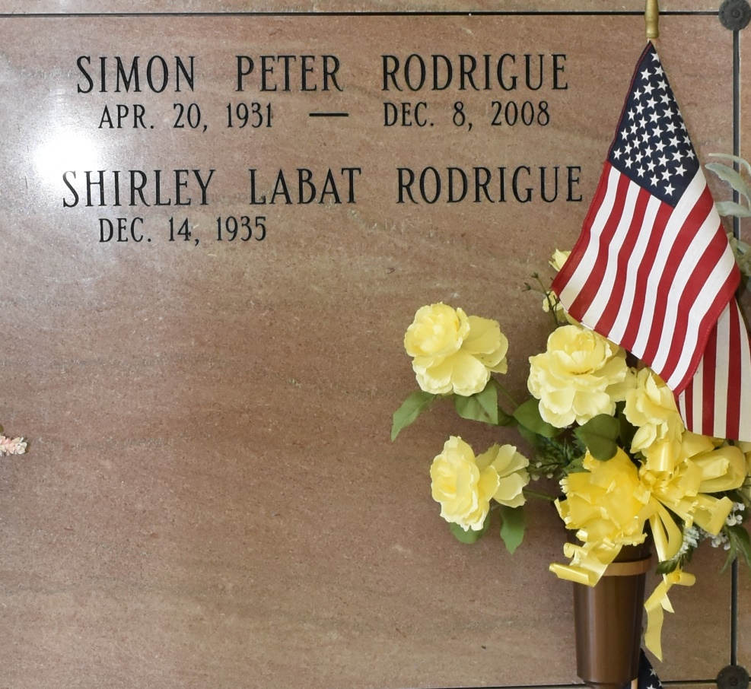

Simon Peter Rodrigue, 77, a native of Chackbay and resident of Vacherie for 56 years, died at 1:40 p.m. Monday, Dec. 8, 2008.

Visitation will be from 8 a.m. to funeral time Thursday at Our Lady of Peace Catholic Church in Vacherie. Mass will be at 11 a.m. Thursday at the church, with burial in the church cemetery.

He is survived by his wife, Shirley Labat Rodrigue; one daughter, Cheryl Rodrigue Dunnells and husband, Greg Dunnells; two brothers, Adam and Carroll Rodrigue; three sisters, Marjorie “Marge” Bavaret, Madonna Martin and Madeline Kraemer; and one grandson, Philip Dunnells.

He was preceded in death by his parents, Agatha Legendre Rodrigue and Typhy Rodrigue Sr.; two brothers, Typhy Rodrigue Jr. and Joseph Rodrigue; and one sister, Genevieve Borne.

He was a veteran of the Korean War.

Thibodaux Funeral Home is in charge of arrangements.

Houmatoday.com

December 10, 2008