Todd Michael Rodrigue

November 1, 1968 – November 13, 2015

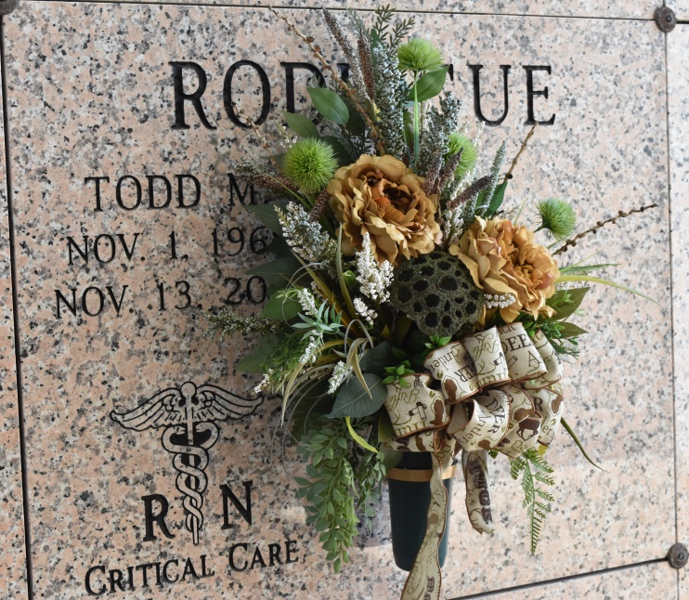

Todd Michael Rodrigue, 47, a native of Chackbay, LA and a resident of Vacherie, LA, passed away on Friday, November 13, 2015 following a 7 month battle with cancer. He was born November 1, 1968.  
 Visitation will be held on Tuesday, November 17, 2015 from 8:00 am to 11:00 am at Our Lady of Peace Catholic Church in Vacherie, LA. A Mass of Christian Burial will be celebrated at 11:00 am at the church followed by burial in the church cemetery.  
 He is survived by his wife, Kelly Falgoust Rodrigue; mother, Sherry Stevens Rodrigue of Chackbay, LA; son, Ty Daniel Rodrigue; daughter, Taylor Michelle Rodrigue; brother, Tim Rodrigue and wife Darlene; sister Stephanie R. Teague and husband Mark, brother-in-law, Keith Falgoust and wife Vicki; sister-in-law Karen Tregre and husband Chris Sr.; father-in-law and mother-in-law, Peter Daniel Falgoust and Alice Falgoust of Vacherie, LA; nieces and nephews, Trey and Madison Rodrigue, Typhanie Teague, Brooke Chauvin, Nicholas and Lauren Falgoust, Kayla Tregre and Chris Tregre Jr.  
 He is preceded in death by his father, Typhy Rodrigue Jr.; grandparents, Typhy Rodrigue Sr. and Agatha Rodrigue, Harris and Louis Stevens.  
 Todd was a nurse for 23 years having practiced at Terrebonne General Medical Center as well as CCU Unit Coordinator for the past 13 years at Thibodaux Regional Medical Center. Accomplished Nurse of the Year Award. His knowledge and care giving skills in the field of nursing will be missed by many. He enjoyed hunting, home brewing, cooking, pistol competition, fishing, and gardening.   
 Arrangements entrusted to Thibodaux Funeral Home of Thibodaux, LA.

Unknown source