Algest “Jerry” Rodrigue

July 5, 1907 – June 13, 1980

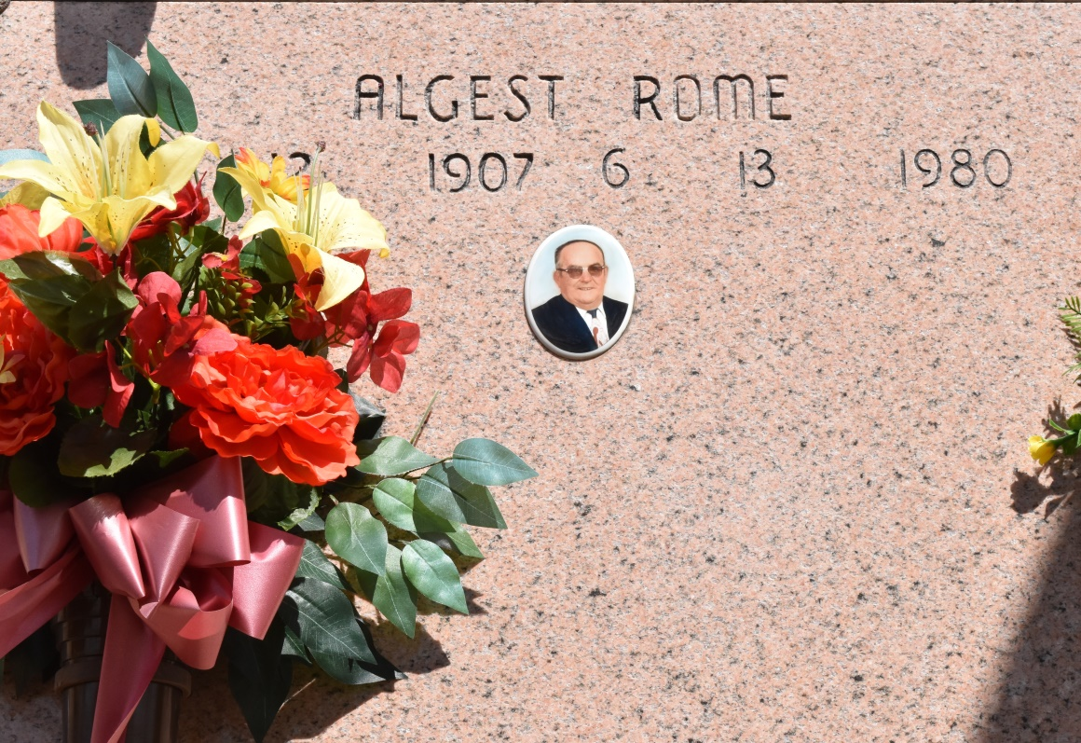

Died at 1:30 a.m. Friday, June 13, 1980, at West St. James Hospital, Vacherie. He was 73, a native and resident of Vacherie. Visiting at Our Lady of Peace Church Hall,, Vacherie, from 8 to 9:45 a.m. Saturday. Religious services at 10 a.m. Saturday at the church, conducted by the Rev. James Kinkaid. Entombment in the church mausoleum. Survived by two sisters, Mrs. Leonard (Marceline) Falgoust and Mrs. Rupert (Nanette) Becnel, both of Vacherie; two brothers, Orlando and Ozie Rome, both of Vacherie. Preceded in death by his wife, Edna Stein Rome; his parents, Helier and Elodia Rome, and a brother, Arsene Rome. Ourso Funeral Home, Donaldsonville, in charge of arrangements.

Unknown newspaper clipping