Lloyd J. Rome Sr.

September 14, 1926 – January 16, 2006

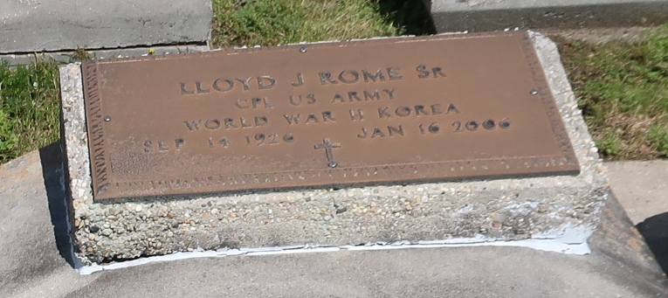

Lloyd J. Rome Sr., 79, son of Frank Rome and Martil Scioneaux Rome, was born Sept. 14, 1926, at Vacherie, La. He died Jan. 16, 2006, at National Health Care at West Plains. He married Margie Haydel Sept. 13, 1956. They were married 31 years and had two children. Mr. Rome served in the U.S. Army from Jan. 29, 1945, to April 30, 1955. He was a decorated veteran with two U.S. Service Medals, two Bronze Stars, two Good Conduct Medals, a National Defense Medal, Korean Service Medal, an American Theater Medal, Victory Medal and World War II Medal. He was a member of the Veterans of Foreign Wars and American Legion. He was an auto mechanic for the state of Louisiana. After he became ill, he moved to Missouri to be cared for by his son. He was preceded in death by his wife; brothers, Eddie Rome, Clifton Rome, Tillman Rome and Harry Rome; and sisters, Rosemary Rome and Florence Chaisson. Surviving are his children, Denise White of Prairieville, La., and Lloyd Rome Jr. of Birch Tree; brother, Leroy Rome; and sisters, Adeline Meguis, Doris Richardale and Lucy Hyme; and three grandchildren. Local arrangements were under the direction of Bradford Funeral Home of Summersville. Burial was in Our Lady of Peace Catholic Cemetery at Valcheri, La., under the direction of Ourso Funeral Home.

Unknown source