Ozie Joseph Rome

May 2, 1913 – July 22, 1995

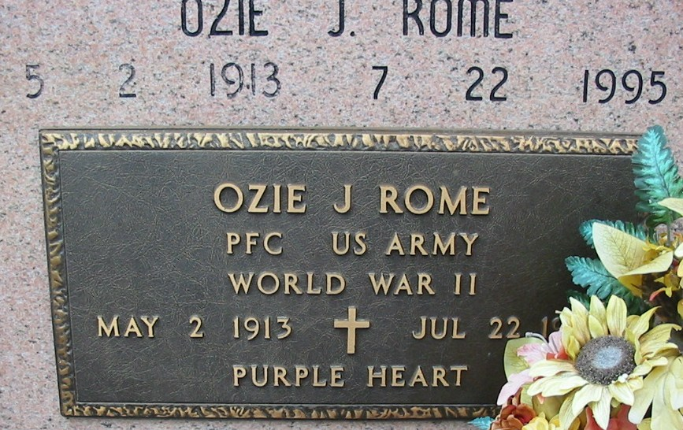

Photo by Bobby

A Mass of Christian burial will be celebrated at 10 a.m. Tuesday at Our Lady of Peace Catholic Church in Vacherie for Ozie J. Rome, 82, a native and resident of Vacherie, who died at 8:54 a.m. Saturday, July 22, 1995. Visitation will be 8 a.m. to funeral time Tuesday at the church. Burial will be in the church cemetery.

He was the father of Gerald P. Rome.

He was preceded in death by his wife, Laura Falgoust Rome; parents, Helier and Elodia Folse Rome; three brothers, Orland, Arsene and Algest Rome; and two sisters, Nannette Becnel and Marceline Falgoust. Landry’s Funeral Home Inc. is in charge of arrangements.

Unknown source