John Rouge

January 3, 1925 – May 10, 2001

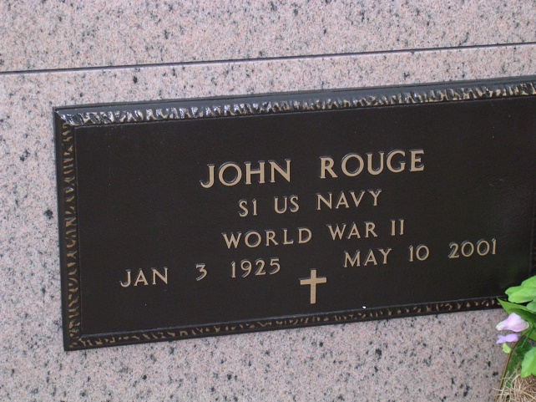

Photo by rrcar

John Rouge  
  
\* age 76, a native and resident of Vacherie, who died at 5:25 a.m. May 10, 2001  
\* mass of burial celebrated Saturday at Our Lady of Peace Catholic Church in Vacherie; visitation today and Saturday at Our Lady of Peace Community Center; interment at the church mausoleum  
\* husband of Bessie Webre Rouge of Vacherie; father of Juliette Pitre of Thibodaux, Nora Duet, Celeste Cortez, Amelia Alleman, Kent and Joshua Rouge, all of Vacherie, Wendall Rouge of Chackbay, Robert Rouge of Kraemer and Dominic Rouge of Choctaw; and brother of Maria Webre of Vacherie, Clara Guidry of Chackbay and Ursula Chenier of Baton Rouge  
\* also survived by 24 grandchildren and 12 great-grandchildren  
\* preceded in death by his parents, Wallace and Amelia Ockmond Rouge of Vacherie; six infant children; grandchildren, Cherise Cortez and Gideon Rouge; and brothers, Lucien, Camille and Louis Rouge  
\* U.S. Navy veteran of World War II serving on the U.S. Ellet; ship fitter at Avondale Shipyard for 30 years  
\* Ourso Funeral Home of Donaldsonville

Unknown source

Contributed by rrcar