Sheila (Gibson) Roussell

July 18, 1951 – May 4, 2018

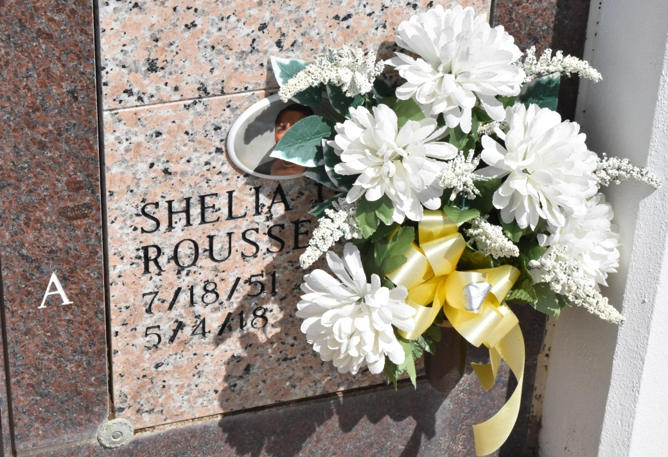

A native and resident of Vacherie. She passed away at St. James Parish Hospital in Lutcher, on Friday, May 4, 2018 at 8:41 a.m. She was 66. Visiting at Word of Life Christian Center, 40066 Highway 22, Darrow, on Friday, May 11, 2018 from 10:00 a.m. until religious services at 11:00 a.m., conducted by Apostle Leroy Thompson, Sr. Interment will be in private. Survived by her husband: Mervin Roussell. Daughters: Laholmer Mitchell, Loreal Roussell and LeShae (Ron) Duhon. Her son: Demond Roussell. Sisters: Valerie (Clifford) Simon, Mary Gibson, Melanie (Ronald) Boudreaux, Charlene Hickerson and Cynthia Arnold. Brothers: Henry, Michael and Charles Gibson. Brothers-in-law: Warren Roussell and Alvin (Eva) Roussell. Four grandchildren, three great-grandchildren, numerous aunts, uncles, nieces, nephews, cousins, godchildren, other relatives and friends. Preceded in death by her parents: Henry Gibson, Sr. and Odelia Dumas Gibson. Two brothers: Mark and Jerome Gibson. BRAZIER-WATSON FUNERAL HOME IN CHARGE OF ARRANGEMENTS. Visit us at [www.brazierwatson.com](http://www.brazierwatson.com/) to sign our guest book.

The Advocate, Baton Rouge, Louisiana

May 9 to May 11, 2018