Alfred Joseph Schexnayder

July 31, 1941 – September 15, 2020

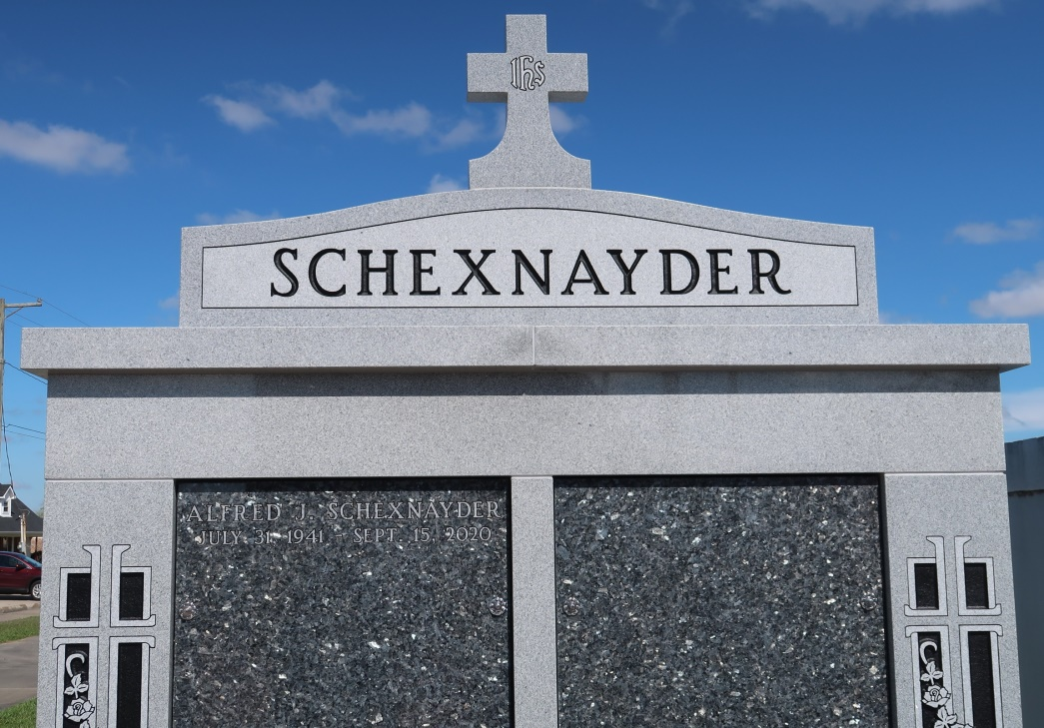

Alfred Joseph Schexnayder, 79, a native and resident of Vacherie, passed away peacefully on Tuesday, September 15, 2020.  
 Visitation will be held at the Thibodaux Funeral Home on Friday, September 25, from 6 p.m. to 9 p.m. A Mass of Christian Burial will be held in his honor at Our Lady of Peace Catholic Church in Vacherie on Saturday, September 26 at 11 a.m., with burial to follow in the church cemetery.  
 He is survived by his loving wife Sandra Clement Schexnayder of Thibodaux; son Todd Schexnayder; daughters Susan Schexnayder Bellanger (Troy) and Nicole Schexnayder Negron (Jorge); grandchildren, Joshua Joseph Bellanger and Victoria Antoinette Bellanger; brother Gerard Schexnayder (Fay); sisters Carrabelle Scotton (Rodney), Rose Pipes (Steve), and Claire Delatte (Brian).  
 He was preceded in death by his parents, Simon Schexnayder and Antoinette Falgoust Schexnayder; twin sister Mary Ann Schexnayder; father-in-law, Ernest Clement and mother-in-law, Victoria Clement.  
 Alfred was a man of faith. Throughout his life, Christ was always at the center. He raised his family in his hometown of Vacherie, a community he truly loved and vowed to never leave.  
 Following in his father’s footsteps, he owned and worked every day at Schexnayder’s Supermarket and eventually ventured into catering. His love for cooking and ability to make anything he touched beautiful quickly made him a success. He was able to be a part of the most memorable moments in people’s lives, which he was passionate about and was always there to lend a helping hand.  
 He inherited his mother’s green thumb and loved working in his yard. However, being a grandfather brought him the most joy in his life. He adored sharing in and being a part of all of their life experiences. He treasured his life and lived it to the fullest, while taking nothing for granted. He will be greatly missed, but never forgotten.  
 The family would like to give special thanks to Will Benoit, Dr. Kyle Guidry, Dr. Francis Robichaux, Dr. Paul Monier, Thibodaux Regional Medical Center and the nurses from the Home Health Center of Thibodaux Regional for their excellent care and compassion.  
 Thibodaux Funeral Home, Inc. is in charge of arrangements.  
  
Houma Today, Terrebonne Parish

September 21-23, 2020