Lorne J. Schexnayder Jr.

December 29, 1981 – October 9, 2007

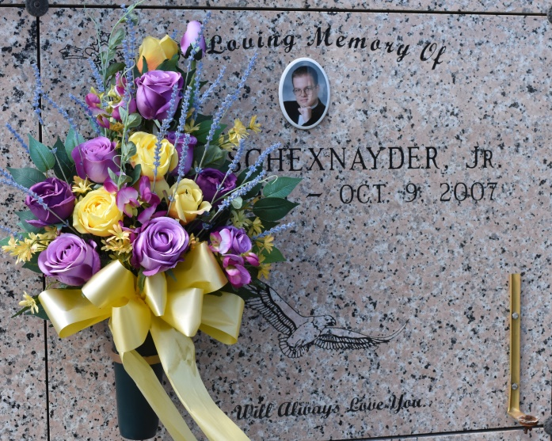

Lorne J. Schexnayder, Jr., age 25, born December 29, 1981, died on October 9, 2007. He was a resident and native of Vacherie, LA.

Survived by parents, Lorne Schexnayder, Sr. and Stephanie Schexnayder; 1 brother, Lee Schexnayder; grandparents, Roy and Sylvia Borne and Juanita Schexnayder. Also survived by numerous family and friends. Preceded in death by grandparent, Fernand Schexnayder.

He was a member of The South Vacherie Volunteer Fire Dept. and Knights of Columbus. He was also a Security Officer for Treasure Chest Casino.

Visitation from 8:00AM until funeral time on Saturday, October 13, 2007 at Our Lady of Peace Catholic Church, Vacherie, LA. Mass of Christian Burial at 12:00PM on Saturday, October 13, 2007 at Our Lady of Peace Catholic Church, Vacherie, LA. Interment Our Lady of Peace Cemetery, Vacherie, LA. Thibodaux Funeral Home, Inc., Thibodaux, LA, in charge of arrangements.

The Times-Picayune, New Orleans, Louisiana

October 12, 2007  
Contributed by Jane Edson