Neva (Rome) Schexnayder

June 16, 1905 – November 16, 1991

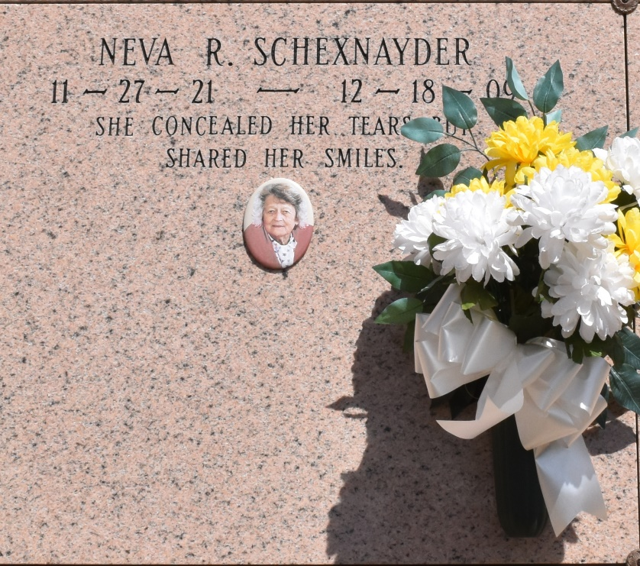

Neva Rome Schexnayder, 88, a native and resident of Vacherie, died at 6 a.m. Friday, Dec. 18, 2009. Visitation will be from 8 a.m. to funeral time Tuesday at Our Lady of Peace Catholic Church in Vacherie. Mass will be 11 a.m. Tuesday at the church, with burial in the church cemetery. She is survived by three sons, Johnny A. Schexnayder and wife, Judy, of Vacherie, Glenn W. Schexnayder and wife, Barbara, of Belle Chasse, and Dr. Denis B. Schexnayder Jr. and wife, Pandora, of San Ramon, Calif.; one daughter, Diana Galliano and husband, Russell, of Thibodaux; one brother, O'Neil Rome of Vacherie; one sister, Pearl Scioneaux of Vacherie; 12 grandchildren; 12 great-grandchildren; and two great-great-grandchildren. She was preceded in death by her husband, Denis B. Schexnayder Sr.; her parents, Arsene Rome and Annette Stein Rome; and one brother, Lester Rome. She was a parishioner of Our Lady of Peace Catholic Church in Vacherie. Landry's Funeral Home is in charge of arrangements.

Unknown source