Laura Marie (Faucheux) Scioneaux

April 29, 1947 – April 27, 2005

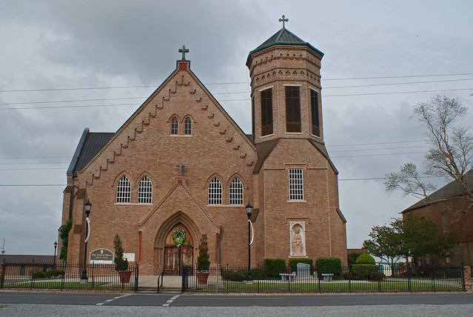

Laura Marie Faucheux Scioneaux, born April 29, 1947, died on Wednesday, April 27, 2005 at 1:58 P.M. Age 57 years. A native and lifelong resident of Vacherie, LA. She was a dedicated teacher at St. Joseph Elementary School in Thibodaux, LA for 26 years. Visitation 9:00 A.M. until funeral time on Friday, April 29, 2005 at Our Lady of Peace Catholic Church, Vacherie, LA. Mass of Christian Burial 11:00 A.M. on Friday, April 29, 2005 at Our Lady of Peace Catholic Church, Vacherie, LA. Interment Our Lady of Peace Mausoleum, Vacherie, LA. Survived by: husband of 36 years, Ronald P. Scioneaux; 2 sons: Shane Scioneaux and his fiance', Amy Champagne and Jason and his wife, Doreen Scioneaux; 1 brother, Paul Zeringue of Vacherie, LA; 2 sisters: Elizabeth Zeringue of Plattenville, LA and Claire Tassin of Vacherie, LA; grandchildren: Devan, Jamie and Ethan Scioneaux. Preceded in death by: parents: Maisy and Lucien E. Faucheux; 2 borthers: Lionel Zeringue and Lucien E. Faucheux, Jr. LANDRY'S FUNERAL HOME, INC. in charge of arrangements.

The Times-Picayune, New Orleans, Louisiana

Apr. 29, 2005