Monte Thomas Scioneaux

March 29, 1947 – November 24, 2009

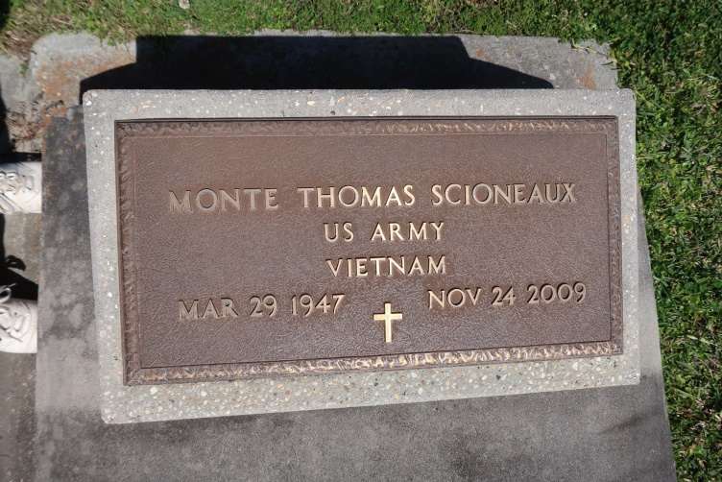

Monte Thomas Scioneaux, a retired welder with Avondale Shipyard, passed away on Tuesday, November 24, 2009.

Beloved son of the late Unness "Joseph" and Mazel M. Scioneaux. Brother of Mary Alice Bernard and Elvin "Duke" Scioneaux. Uncle of Tara Gassenberger, Tonya Barnum, Lindsey Bernard, and Shaun Bernard. Age 62 years, a native of Vacherie, LA and resident of Thibodaux, LA.

Relatives and friends of the family are invited to attend a Funeral Service in the Chapel of MOTHE FUNERAL HOME, 7040 Lapalco Blvd., Marrero, LA on Tuesday, December 1, 2009 at 9:00 AM. Interment Our Lady of Peace Cemetery, Vacherie, LA. Visitation at the funeral home Tuesday from 8:00 AM until 9:00 AM. For further information or directions, call 504.366.4343.

The Times-Picayune, Baton Rouge, Louisiana

Nov. 29, 2009