Roy Scioneaux Jr.

May 30, 1970 – May 26, 2017

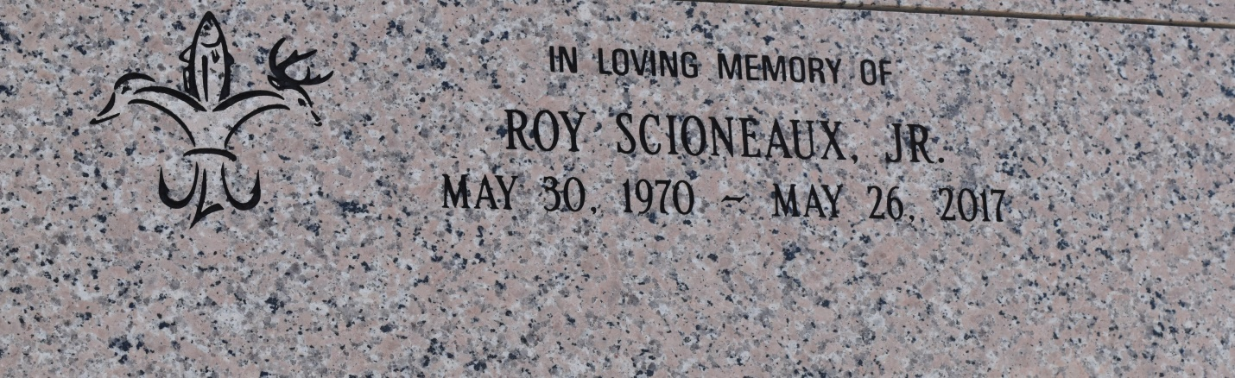

Roy Scioneaux Jr., 46, was born on May 30, 1970, and passed away on May 26, 2017. He was a native and resident of Vacherie.  
  
A visitation will be held on Thursday, June 1, 2017, at Our Lady of Peace Catholic Church from 8:30 a.m. until service time. A Mass of Christian Burial will take place at 11 a.m. Interment will follow in the church cemetery.  
  
He is survived by his mother, Bertha Scioneaux; godchildren, Raven and Eric Salas; brother, James Scioneaux; girlfriend, Barbara Salas; and grandmother, Dazeria Matherne.  
  
He was preceded in death by his father, Roy Scioneaux Sr.; grandparents, Eva and Nelson Scioneaux; and grandfather, Antoine Matherne.  
  
Thibodaux Funeral Home, Inc. is charge of arrangements.

Houma Today, Terrebonne Parish, LA

May 30-31, 2017