Albert Joseph Simon

March 22, 1920 – June 5, 2016

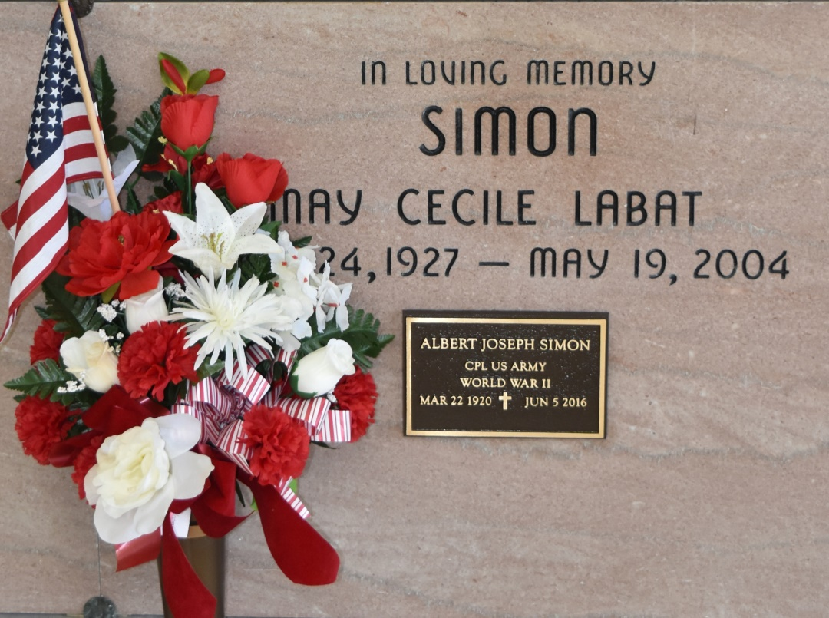

Albert Joseph Simon passed away on Sunday, June 5, 2016 at the age of 96. He was a lifelong resident of Vacherie, LA. Visitation will be on Wednesday, June 8, 2016 from 8:00 am until funeral time at 12:00 noon at Our Lady of Peace Catholic Church in Vacherie, LA with burial following in the church cemetery. He is survived by his four children, Selma Simon, Annie Falgoust (Brian), Reggie Simon (Myra) of Vacherie, and Mark Simon (Connie) of Thibodaux; seven grandchildren and seven great-grandchildren (with another due in December); his siblings, Hermine Brack, Maude Simon, Alice Falgoust (Percy), and Lois Chenier (Bobby). He was preceded in death by his wife, May Labat Simon; his parents, Hermenegilde and Georgine Simon; and sister, Claire Rodrigue, and baby brother, Megilde Simon. He was a WWII Army Combat Veteran and served in the Pacific Campaign from 1942-1945. A special thanks to all the family, friends and caregivers, who cared for him over the last few months. Thibodaux Funeral Home, Inc. is entrusted with handling the funeral arrangements.

Advocate, The (Baton Rouge, LA)

Monday, June 6, 2016  
Contributed by Jane Edson