Leo Jean Simon

October 10, 1929 – August 5, 2014

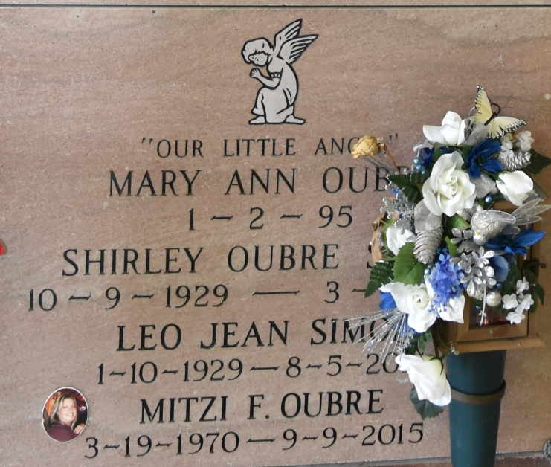

Leo Jean Simon, 85, a resident and native of Vacherie, passed away Tuesday, Aug. 5, 2014, at Lafourche Nursing Home in Thibodaux.  
 Visitation will be from 9 a.m. until funeral time Friday at Our Lady of Peace Catholic Church in Vacherie. A Mass of Christian burial will be at 11 a.m. Friday at the church, with burial in the church cemetery. Pallbearers will be Todd Falgoust, Chase Ordoyne, Peter Oubre, Cody Oubre, Heath Marse, and Shawn Schexnayder.  
 He is survived by his daughter; Cheryl Simon; sisters, Therese Cazenave, Lena Himel, Mae Martinez, Ella Dempster and husband, Callen, and Kate Wood and husband, Kenneth; brother, Larry Simon and wife, Patsy; grandchildren, Todd Falgoust, Mitzi Oubre, and Kristi Marse; great-grandchildren, Kayla Falgoust, Britney Schexnayder, Rebecca Falgoust, Chase Ordoyne, Cody Oubre, Lexi Marse, and Karli Marse; and great-great-grandchild, Raygen Schexnayder.  
 He was preceded in death by his parents, Lionel and Annette Amedee Simon; wife, Shirley Simon; son, Lonny Simon; sister, Lea Simon Becnel; and grandchild, Mary Oubre.  
 Leo was retired from Avondale Shipyard.  
 Please visit [www.oursodonaldsonville.com](http://www.oursodonaldsonville.com/) to sign the online register book.  
Ourso Funeral Home in Donaldsonville is in charge of arrangements.

Houma Today, Terrebonne Parish, Louisiana

Aug. 5 to Aug. 6, 2014.