Rose (McGowan) Simon

October 24, 1904 – April 17, 1969

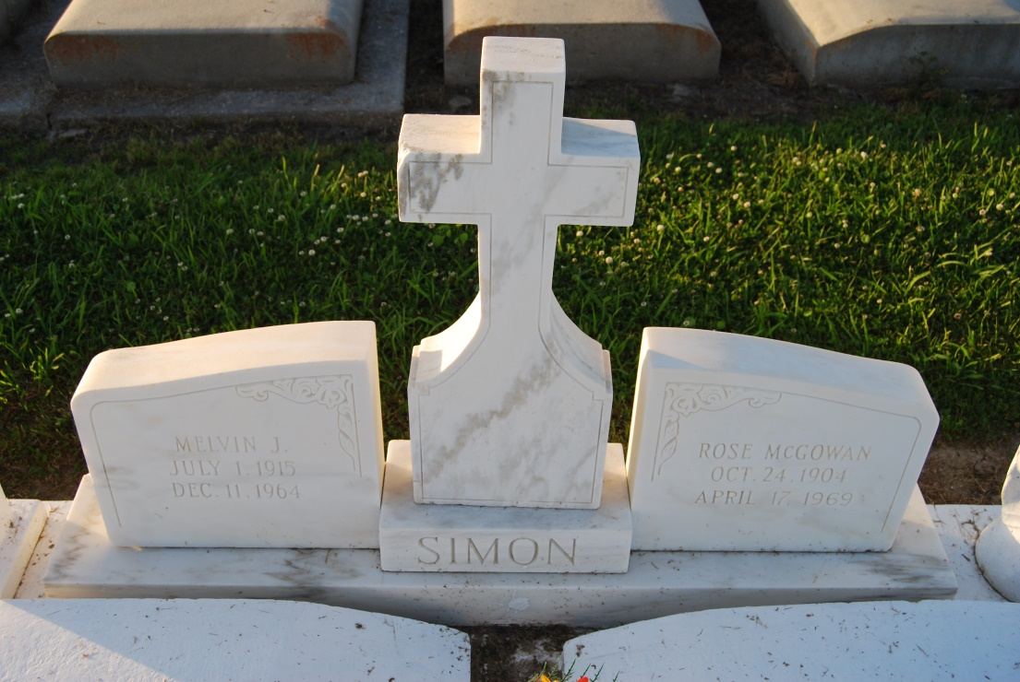

Photo by Kerry Keller

1908 Louisiana Orphan Train Rider   
  
 She was natural born child of Annie Kelly & John McGowan. On Feb 28, 1909, Rose was placed in the foster home of Mr. Joseph Constant Falgoust and his sister, Miss Euphemia Falgoust of Vacherie. She was formally indentured on Feb 28, 1911 to Mr. Joseph Falgoust and Miss Euphemia Falgoust.   
 Rose married John William Inness (1902-1968) on April 27, 1921. They had 4 children. John; Tracy Lenard; Emerante Rose Triche; Francis Conrad. They divorced in 1937.   
 Rose married in a civil ceremony on Jan 31, 1938 to Melvin Joseph Simon (1915-1964). Melvin died Jan 11, 1964. One child, Elizabeth "Betty" Jane Simon Zeringue Tabor.   
 Rose inherited a 168 acre sugarcane farm to be known as The Rose McGowan Simon Farm, Inc.   
  
From *Cradle to Grave* by Louisiana Orphan Train Society, Inc.

Contributed by Kerry Keller