Victorine Marie (Dumas) Simon

December 18, 1932 – May 24, 2003

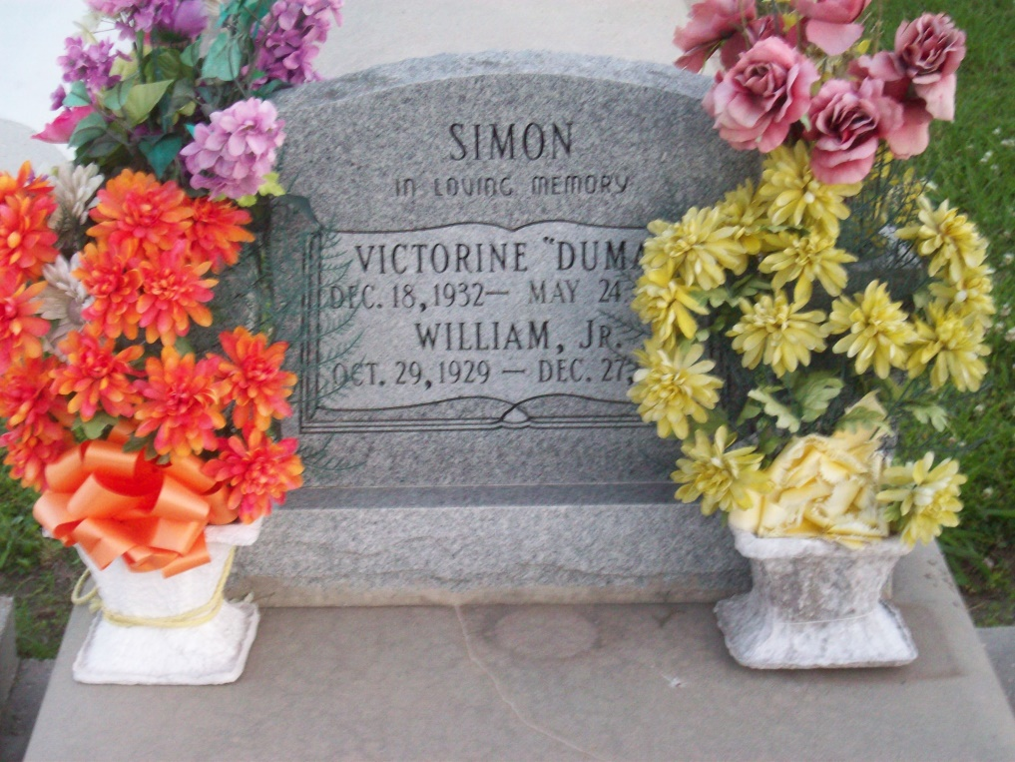

Photo by TMB

Victorine Marie Simon, on Saturday, May 24, 2003 in Vacherie, LA. Wife of the late William Simon, Jr., daughter of the late Rosemary and Paul Dumas, Sr. Mother of Beverly (Antoine) Bailey of Marrero, LA. Jacqueline (Rodney) Guss of Hahnville, LA., Jeanolia Simon of Dallas, TX., Martin (Mary) Simon of Houston, TX., Melvin (Mary), Larry (Carolyn), George, Leo (Amanda) and William III (Tharon) Simon, all of Vacherie, LA. Sister of Wilborine Steib, Mary Jane Greeman, Celeste Marie James, Leo Paul, Whitney, Russell, and Anthony Dumas and the late Agnes Dumas Wooden, Harry, John and Haywood Dumas. Also survived by 14 grandchild and a host of nieces, nephews other relatives and friends. A native and resident of Vacherie, LA. Age 70yrs.  
 Relatives and friends of the family, also KPC Ladies Auxiliary Court #161, Good Children Society and neighboring churches are invited to attend the Funeral Services on Friday, May 30, 2003 at at 11:00 A.M. from Our Lady of Peace Catholic Church, South Vacherie, LA. Rev. Henry Gautreaux - Celebrant. Interment in the church cemetery. Visitation from 8:00 A.M. to Funeral time on Friday at the church. Arrangements by, WILLIAMS & SOUTHALL FUNERAL HOME, Napoleonville, LA 985-369-7231

Times-Picayune, The (New Orleans, LA) - Thursday, May 29, 2003

Contributed by Jane Edson