Angeline (Dumas) Singleton

March 24, 1920 – March 26, 1999

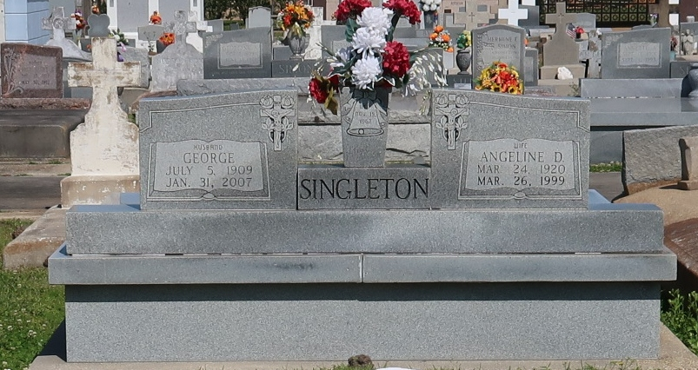

Angeline Singleton, 79, a native of Vacherie, resident of New York City for 50 years and resident of Marrero for three years, died March 26. She was the wife of George Singleton, mother of the late Gilbert Dumas and step-mother of Georgina McKinley and Anna Bell Boyd.  
  
She was daughter of the late Wilfred and Adolestine Dumas; sister of Cora Walker, Alfred, Lumas and Clarence Dumas and the late Enola Narcisse and Wilfred, Dalton and James Dumas.  
  
She is also survived by two grandchildren.  
  
Services were held April 1 at St. Joseph the Worker Catholic Church, Marrero, with interment at Our Lady of Peace Cemetery, Vacherie.

Unknown source