Willie Mae (Keller) Smith

June 1, 1941 – January 29, 2018

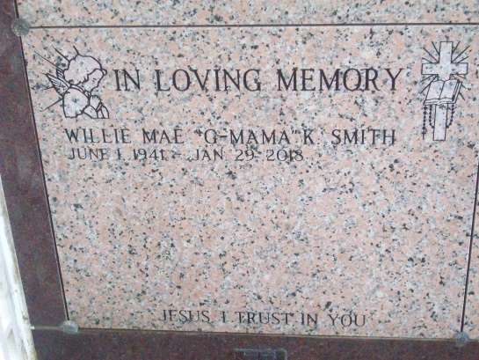

Photo by TMB

Willie Mae Keller Smith, 76, "G-Mama", a native and resident of Vacherie, LA, passed away peacefully on January 29, 2018. She was born on June 1, 1941 to the late Morris and Catherine Keller. She is survived by her two children, Mark Anthony Keller, Sr. and Mary Katherine Smith-Thomas; seven grandchildren: Kaisha, Sean and Haven Thomas; Markeisha and Mark Anthony Keller, Jr.; Malik Joseph and Kenneth Brown; two great-grandchildren: Chasyn Gordon and Kai Thomas; and one godchild: Melan Smith. Also survived by three sisters: Susie St. Juniors of New Orleans, LA; Dorothy Roussel(Wilbert) of Edgard, LA and Margaret Williams of Vacherie, LA; a brother, Larry J. Keller, Sr. (Gloria) of San Antonio, TX; sister-in-law Jessie Mae B. Keller, and a host of relatives and friends. Willie Mae was also preceded in death by her brothers; Clarence Byrd, Morris Keller, Jr., Charles Keller, Sr., sister, Shirley Keller-Daughtry; and godson, Keith Williams. Willie Mae will be celebrated at a Mass of Christian Burial on Saturday, February 3, 2018 from Our Lady of Peace Catholic Church, 13281 LA-644, Vacherie, LA 70090 for 11:00am. Her close personal friend, Father Joshua Johnson, Celebrant. Visitation begins at 8:30am with recitation of the rosary at 9:30am. Entombment in church mausoleum. Her final disposition has been entrusted to Treasures of Life Funeral Services, 315 E. Airline Hwy, Gramercy, LA 70052. 225-258-4039.

Published in The Times-Picayune, New Orleans, LA from Feb. 2 to Feb. 4, 2018