Charles “Plook” Steib

February 1, 1938 – May 15, 2005

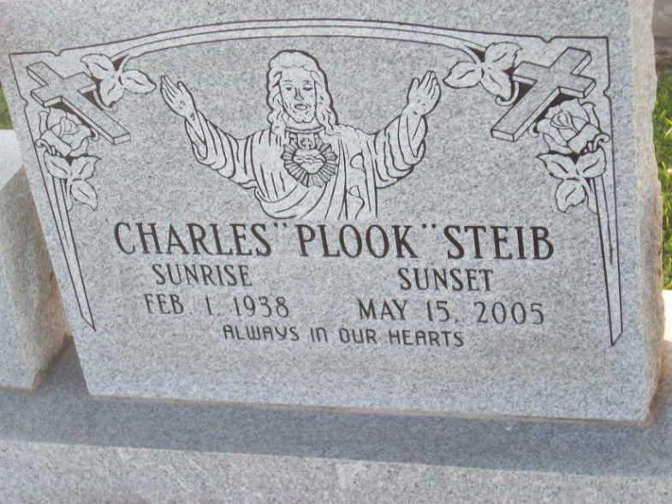

Photo by TMB

Charles ""Plook'' Steib on Sunday, May 15, 2005 at his residence in Vacherie, LA. Husband of Victoria Geason Steib; Father of Jerome (Wendy), Gerald, Sr. (Yvette) Steib of New Orleans, LA, Donovon (Dana), Monica and Cristy Steib, all of Vacherie, LA; Son of Lucille Dumas Steib of Vacherie, LA and the late Clerville Steib, Sr; Brother of Joseph (Cleaster) John, Wilbert and Audrey Steib, all of Vacherie, LA, Rose (Joseph) Long of Lutcher, LA, Geneva (Maurice) Perez of Harvey, LA and the late Raymond and Clerville Steib, Jr. and Caroline Gauthier.

Unknown source

\*\*\*\*\*

Charles Or Plook Steib, 67

A retired operator for Agrico Chemical Plant and a resident and native of Vacherie, he died at 2:45 a.m. Sunday, May 15, 2005, at his home. He was 67. Visiting at Our Lady of Peace Catholic Church in Vacherie on Thursday, May 19, from 8 a.m. until Mass of Christian Burial at 11 a.m., with the Rev. Michael A. Miceli, celebrant. Burial in the church cemetery. He is survived by his wife, Victoria Geason Steib; three sons and spouses, Jerome and Wendy and Gerald Sr. and Yvette Steib, all of New Orleans, and Donavon and Dana Steib of Vacherie; two daughters, Monica and Cristy Steib, both of Vacherie; mother, Lucille Dumas Steib; three brothers, Joseph and wife Cleaster, and John and Wilbert Steib, both of Vacherie; three sisters and two brothers-in-law, Audrey Steib of Vacherie, Rose and Joseph Long of Lutcher and Geneva and Maurice Perez of Harvey; sisters-in-law and their husbands, Rita and Melvin Sutherland and Bernice and Jules Landry of St. James; and brothers-in-law and their wives, the Rev. Charles and Joyce, Earl and Virginia, Bernard and Joyce, Marsden, Lester and Albert Geason Sr., all of St. James, and the Rev. Raymond Geason of Gonzales. He also is survived by seven grandchildren and a host of aunts, uncles, nieces, nephews, other relatives and friends. He was preceded in death by his father, Clerville Steib Sr.; two brothers, Clerville Jr. and Raymond Steib; and a sister, Caroline Gautier. Arrangements by Williams & Southall Funeral Home, Napoleonville.

Advocate, The (Baton Rouge, LA) - Wednesday, May 18, 2005

Contributed by Jane Edson