Clerville P. Steib

February 22, 1908 – August 18, 1991

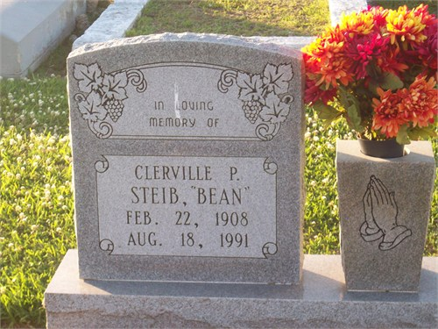

Photo by TMB

Religious services will be held at 11 a.m. Wednesday at Our Lady of Peace Catholic Church in Vacherie for Clerville Pierre ''Bean" Steib, 83, a native and resident of Vacherie who died at 7.55 p.m. Sunday.  
 Visitation will be from 8 a.m. until funeral time Wednesday at the church.   
Interment will be in the church cemetery.  
 He was the husband of Lucille D. Steib: father of Charles, Raymond. Joseph, John, Audrey and Wilbert Steib, all of Vacherie, Rosemary Long of Lutcher, Caroline Gautier of New Orleans and Geneva Perez of Harvey; brother of Rosomond Steib Jr., Valerie Mitchell of Marrero, Veronica Lemieaux and Frances Gros both of Vacherie and Viola Narcisse of LaPlace. He is also survived by 22 grandchildren and five great-grandchildren.  
 He was preceded in death by a son, Clerville Steib Jr.; parents, Eugenia Phillip and Rosomond Steib Sr., brothers, Aurelian, Andre and Sylvester Steib; and a sister, Elodie Jessie.

Unknown source