Firmin Steib
January 27, 1918 – December 17, 2003

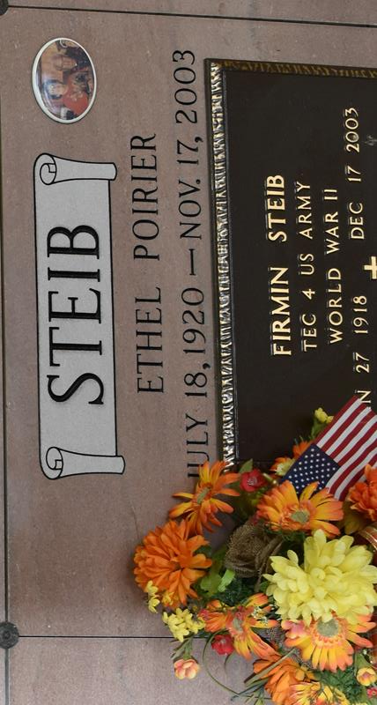

A loving father, grandfather and great-grandfather, he passed peacefully on Wednesday, Dec. 17, 2003, at his daughter's home in Vacherie. He was a long-time resident of Vacherie, a U.S. Army veteran of World War II and a retired employee of Kaiser Aluminum in Gramercy. He was 85.
Survived by a daughter, Judy Folse and husband Stanley "Dip" Folse; a son, Ronald Steib and wife DeLane Steib, all of Vacherie; six grandchildren, Kim Adams and husband Patrick Adams, Timmy Folse and wife Melissa Folse, Mary Beth Scorsone and husband Michael Scorsone, all of Vacherie, Rhonda Green and husband Joel Green of Baton Rouge, Rebecca Saunders and husband Brian Saunders of Metairie and Renee Steib of Baton Rouge; seven great-grandchildren, Alex and Whitney Adams, Bradley and Collin Folse and Katherine, Caroline and Elizabeth Scorsone; sisters, Lise Falgout, Lucille Steib and Pauline Perez, all of Westwego, Irene Bourgeois of Donaldsonville, and Margaret "Noonie" Naquin of Thibodaux; and a brother, Sidney Steib of Westwego. He was preceded in death by his wife of 59 years, Ethel Poirier Steib; parents, Donald and Emelia Rodrigue Steib; and brothers, Whitney, Julien and Paul Steib.
Visitation will be at St. Philip Catholic Church from 8:30 a.m. until Mass at 11 a.m. Saturday, Dec. 20, 2003. Internment will take place at Our Lady of Peace Cemetery in Vacherie. Pallbearers will be Jimmy Dufresne, Prudent Steib, Clayton Perque, Barry Delatte, Willis Poirier and Joseph Weber. His talents to fix things will always be remembered. Rose Lynn Funeral Services, 225-869-0000, 1870 Cabanose Ave., Lutcher, LA 70071 (off La. 3125) in charge of arrangements.

Advocate, The (Baton Rouge, LA)
Friday, December 19, 2003

