Gosilia A. (Isom) Steib

August 30, 1939 – September 18, 1999

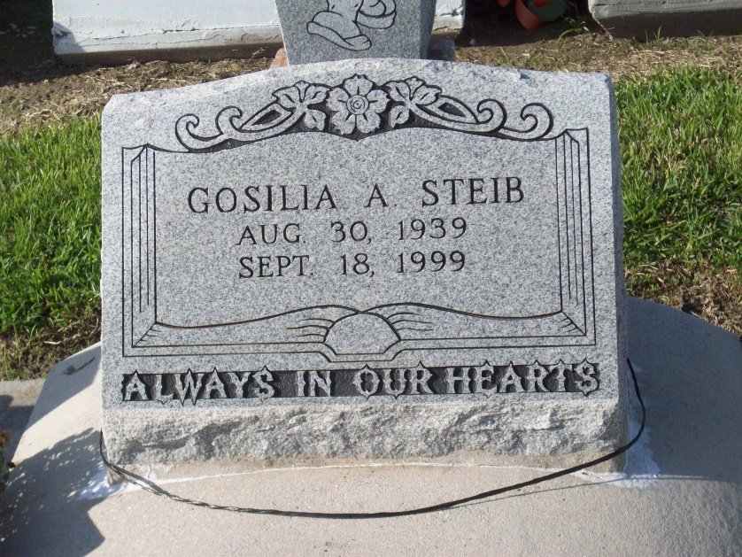

Photo by TMB

Gosilia Isom Steib, 60, a native and resident of Vacherie, died Sept. 18. She was the wife of the late Joseph Calvin Steib and mother of Colleen Hurst and Jo-Ann, Jennifer, Aleitha, Joseph Jr. and Brian Steib.She was also the daughter of the late Albertha Lemieux and Eli Isom and sister of Eloise Bartholomew Louvinia Dumas, Henry and Joseph Isom and the late Agnes Tassin, Helen Nelson, Theresa Oubre and Raymond Isom.   
  
She is also survived by 14 grandchildren and one great-grandchild.

Services are today at 10 a.m. at Our Lady of Peace Catholic Church, SouthVacherie, with interment at the church cemetery. Visitation starts at 8a.m.

L'Observateur (La Place, LA) - Wednesday, September 22, 1999

Contributed by Jane Edson