Hilton Steib Sr.

August 31, 1918 – January 20, 1991

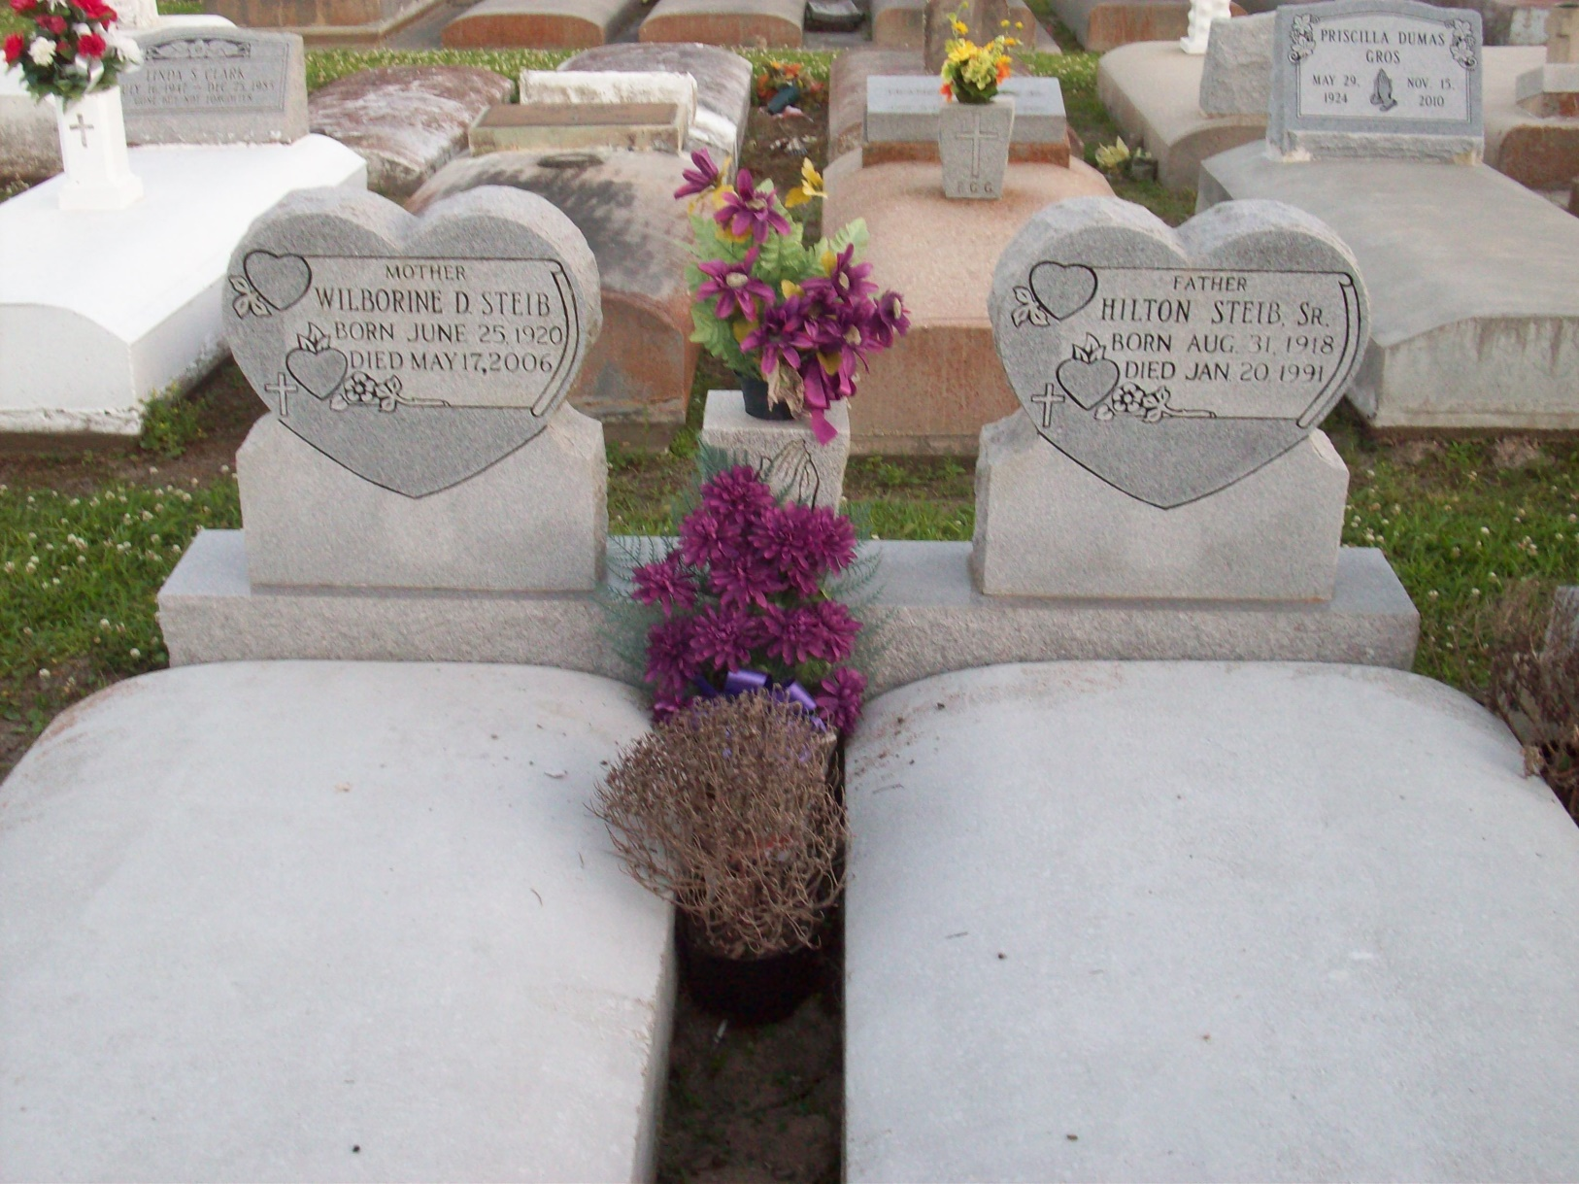

Photo by TMB

Religious services will be held at 11 am Wednesday at St. James Catholic Church in Vacherie for Hilton Steib Sr., 72, a native and resident of Vacherie who died Sunday at 10:45 a.m.

Visitation will be from 9-11 am Wednesday at the church. Burial will be in Our Lady of Peace Cemetery in South Vacherie.

He was the husband of Wilvorine Dumas Steib; father of Hamilton, Vincent, Helton Jr., Preston and Raymond Steib, Christine Fletcher and Rita Charles; brother of Nelson and Sylvester Steib, Floretta, Luvert, Florida, Emma and Amay. He is also survived by 18 grandchildrne and two great-grandchildren.

He was preceded in death by his parents, Sylvester and Amay Oubre Steib; brothers, Calvin and Florin and a sister, Lou Ann.

Southall Westside Funeral Home of Vacherie is in charge of arrangments.

Unknown source

Contributed by Veronica Sampey