Iona Bessie (Lemieux) Steib

December 19, 1914 – September 20, 2008

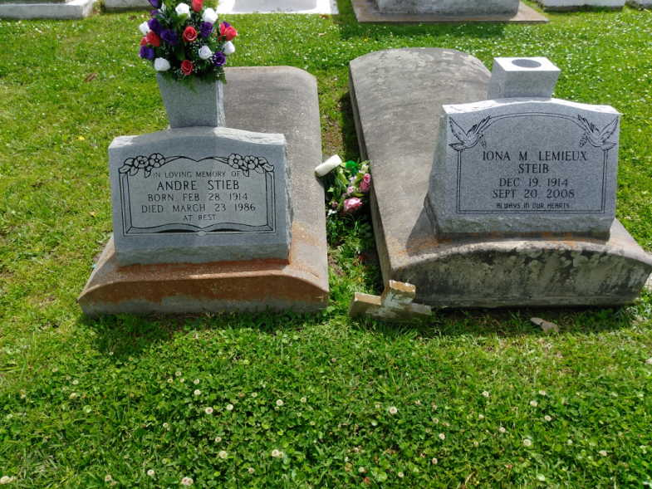

Photo by TMB

A resident and native of Vacherie, she died on Saturday, Sept. 20, 2008. She was 93, born Dec. 19, 1914. Survived by two daughters and sons-in-law, Jacquelyn and Joseph Gros Jr. and Patricia and Claude Baptiste Sr.; grandchildren and spouses, Darryl and Brenda Baptiste, Claude Jr. and Patricia Baptiste, Charles Baptiste, Jennifer Baptiste, Collin Gros and Laural and Michael Howard; and six great-grandchildren, Johannes, Treyvon and Jacory Baptiste, Hailey Gros and Micah and Mora Howard. Preceded in death by her husband, Andre Steib; parents, Louis and Felecie Webre Lemieux; five brothers, Peter, Ulic, Eddie, Kermit and Allen Lemieux; five sisters, Neloa Ellis, Gertrude Solomon, Loretta Lemieux, Geneva Lemieux and Christina Laurent; and grandson, Jeffery Baptiste. Special thanks to the staff and caregivers at Riverlands Health Care Center, St. Catherine's Hospice, St. James Parish Hospital and to everyone who touched her life. Special thanks to the Rev. Michael Miceli. Arrangements by Thibodaux Funeral Home Inc., Thibodaux.

Advocate, The (Baton Rouge, LA) - Monday, September 22, 2008

Contributed by Jane Edson