Joseph Alvin Steib

June 19, 1944 – July 29, 2016

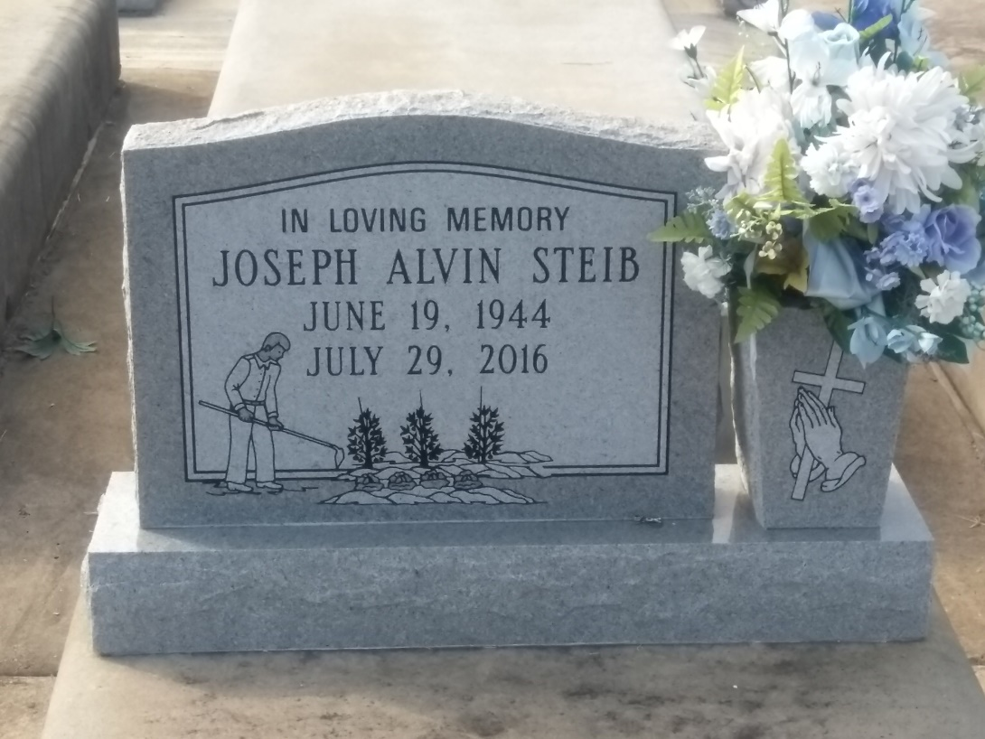

Photo by TMB

Joseph Alvin Steib, affectionately known as "Specky" entered his eternal home on July 29, 2016, surrounded by loved ones at the age of 72. He leaves to cherish his memories, wife Dolores August Steib, children Heather (Rodney Sr.) Batiste, Duran (devoted companion, Kaitlin) Steib; two grandchildren; Ty'ree Steib and Rodney Batiste, Jr. He is also survived by his siblings, brothers in law and sisters in law, Royally (PapPa) Steib, Ronald (Celestine) Steib, Mary(Alton) Long, Diane Singleton, Nelson (Rita) Steib, Cynthia (Alfred) Joseph, James (Shelia) Steib, Mary Theresa Hughes, Donna (Charles) Love, Ronnien (Wanda) Steib, Nadine (Herman) Lewis, Micheal Steib, Darlene(Dwayne) Mayho and a host of nieces, nephews and cousins. Preceded in death by his parents, Nelson and Rose Mary Steib, brothers in law Philip Hughes and Grover Singleton, and sister Ruby Steib Weber.

Unknown source