Joseph Beronie Steib Jr.

July 1, 1950 – December 28, 2005

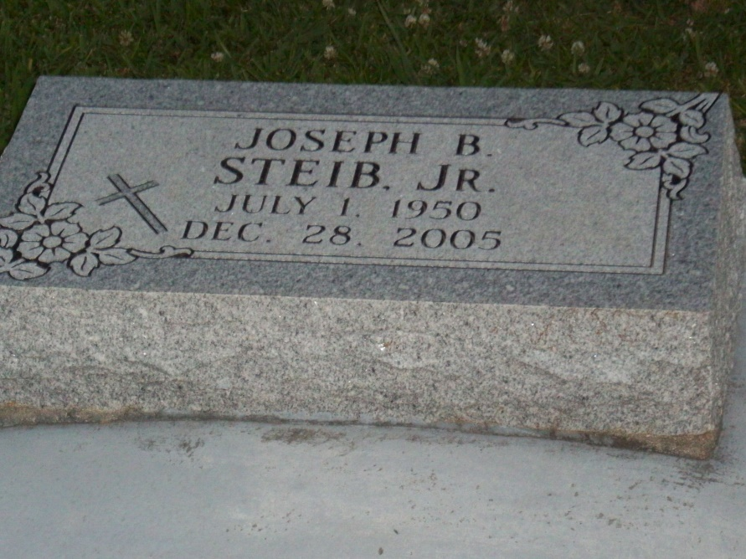

Photo by TMB

Joseph Beronie Steib, Jr. on Wednesday, December 28, 2005 at Lane Memorial Hospital, Zachary, LA. Son of Natalie Dumas Steib and the late Joseph B. Steib, Sr. Brother of Brenda Gaignard, Leo, Tyrone Steib, Janet Steib-Harrison and Tracy Weldon. Brother-in- law of Debbie Steib and Victor R. Weldon. Godson of Audrey Howard and the late Pierre Steib. Godfather of Craig Gaignard. Grandson of the late Eulan and Baldwin Steib and Ephriam and Orelia Dumas. Nephew of Eugenia S. Oubre, Francis Brouet, Barbara Steib, Audrey Howard, James Steib, Sr., John Huntley Steib, and Marion J. Steib. Also survived by a host of nieces, nephews, cousins, friends, and relatives. A native of Vacherie, LA and a resident of Villa Feliciana, Jackson, LA. Age 55 years.  
 Relatives and friends of the family, also priest and parishioners of Our Lady of Peace Catholic Church, employees of St. James Parish School Board, Louisiana Machinery, J.E. Merit, Metropolitan Human Services District, Magnolia High School Class of 1968, Southern University Class of January 1973 are invited to attend a Mass of Christian Burial on Monday, January 2, 2006 at 12:00 (Noon) at Our Lady of Peace Catholic Church, Vacherie, LA. Father Michael Michelli, celebrant. Interment church cemetery. Visitation at the church after 9:00 A.M. Recitation of the Rosary 10:00 A.M.  
 THE BALONEY FUNERAL HOME, L.L.C., 399 Earl Baloney Dr., Garyville, LA 70051 (985) 535-2540 In charge of arrangements.

Times-Picayune, The (New Orleans, LA) - Sunday, January 1, 2006

Contributed by Jane Edson