Joseph Herbert Steib

August 7, 1899 – October 7, 2002

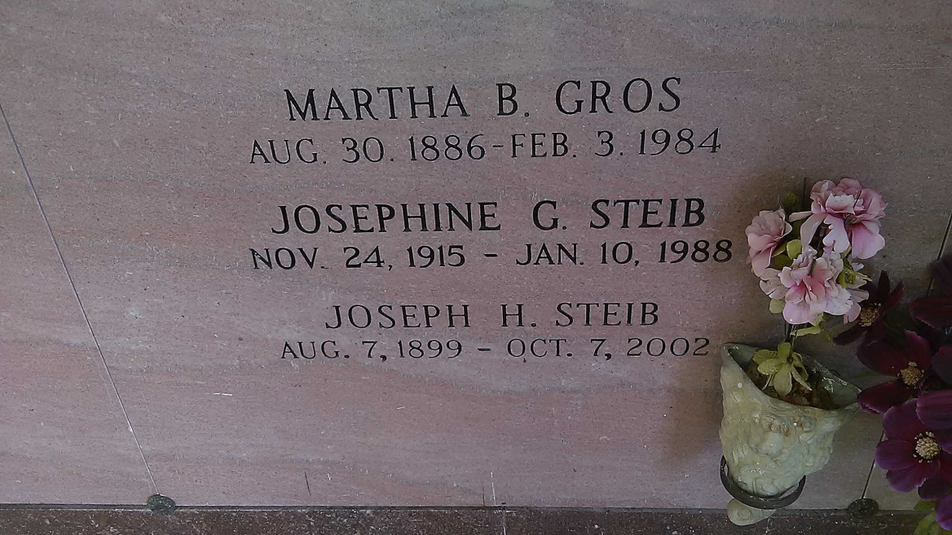

Photo by TMB

Joseph Herbert (Sa-Son) Steib of Vacherie, La. on Mon., Oct. 7, 2002 at Maison DeVille Nursing Home, Houma, La. Son of the late Eugene and Arta Laurent Steib. Husband of the late Josephine Grow Steib. Like-A-Father of Rosalind Solomon Baldauf. Also survived by a host of nieces, nephews, cousins and friends. Preceded in death by his brothers John, Ellis and Lagard Steib. A native and resident of Vacherie, La. Age 103 years.  
  
Relatives and friends of the family, also priest and parishioners of Our Lady of Peace Catholic Church are invited to attend a Mass of Christian Burial on Saturday, October 12, 2002 at 10:00 AM from the Our Lady of Peace Catholic Church, Vacherie, La. Father Louis Oubre Celebrant. Entombment Church Mausoleum. Visitiation at the church after 8:00 A.M. on Sat.  
  
The Baloney Funeral Home in charge of arrangements.

Times-Picayune, The (New Orleans, LA) - Friday, October 11, 2002

Contributed by Jane Edson