Lucille (Dumas) Steib

July 26, 1917 – March 28, 2007

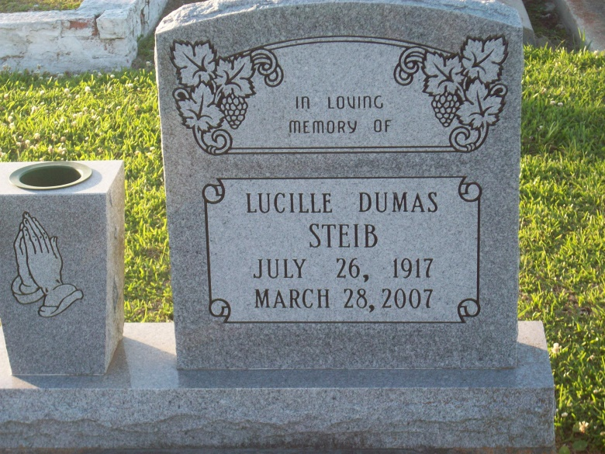

Photo by TMB

Lucille Dumas Steib, 89, a native and resident of Vacherie, died at her residence, Wednesday, March 28, 2007.  
  
She is survived by three daughters, Audrey Steib of Vacherie, Rose S. Long of Lutcher and Geneva S. Perez of Harvey; three sons, Joseph, John and Wilbert Steib of Vacherie; two sisters, Marie Oubre of Vacherie and Lillie Lewis of New Orleans; two brothers, Edward and Henry Dumas Jr. of Vacherie; 25 grandchildren; 18 great-grandchildren; and numerous relatives.  
  
She was preceded in death by her husband, Clairville Steib Sr.; one daughter, Caroline Gautier; three sons, Charles, Raymond and Clairville Steib Jr.; her parents, Henry and Lydia Dumas; one brother, Edwin Dumas; and two sisters, Emily Morton and Louise Young.  
She was a member of Good Children Benevolent Society in Vacherie.

Unknown source