Marion Jean Steib

January 4, 1930 – December 27, 1996

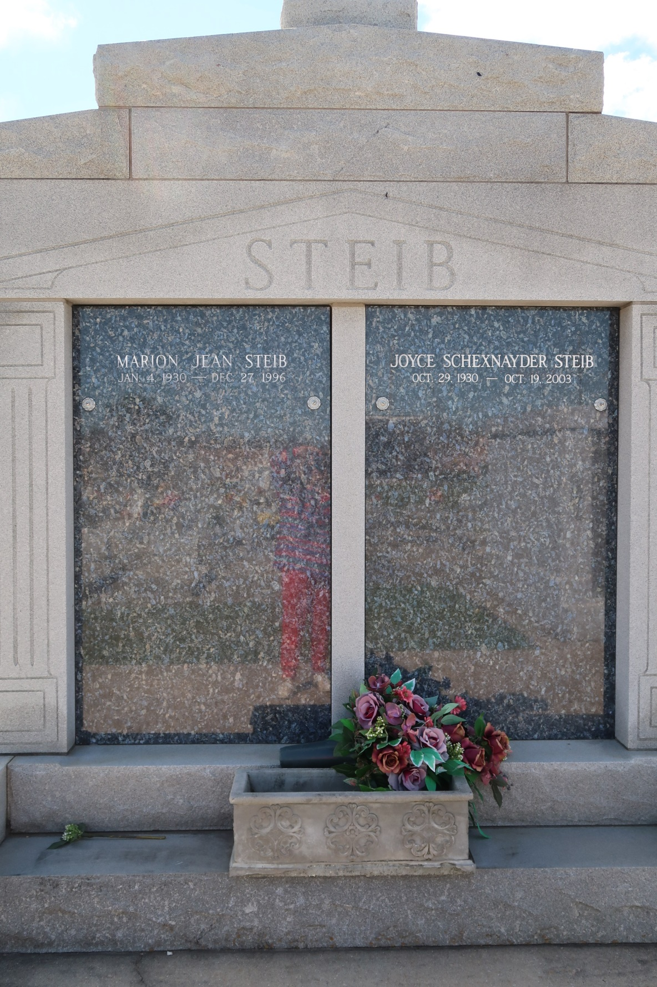

STEIB, MARION

A retired self-employed building contractor and resident and native of Vacherie, he died at 4 p.m. Friday, Dec. 27, 1996, at his residence. He was 66. He was a member of the board of directors of St. James Bank.

Visiting at Our Lady of Peace Catholic Church, Vacherie, 7 a.m. Monday until Mass of Christian Burial at 11 a.m., conducted by the Rev. Clarence Waguespack. Entombment in church mausoleum.

Survived by wife, Joyce Schexnayder Steib; three daughters, Geralyn Steib Millet and Nettie Steib Amedee, both of Vacherie, and Simone Steib Hemilton, Baton Rouge; five sons, William, Lucien and Stephen Steib, all of Chackbay, Damian Steib and Marion Steib Jr., both of Thibodaux; three sisters, Annie Gravois, Elaine Rodrigue and Belle Reulet, all of Vacherie; three brothers, Paul and Charles Steib, both of Vacherie, and Lucien “Jimmy” Steib, Luling; and 19 grandchildren. Preceded in death by parents, Lucien and Angelle Gravois Steib. In lieu of flowers, memorial donations may be made to American Cancer Society.

Advocate, Baton Rouge, La.

Saturday, December 28, 1996, p. 42