Prudent Joseph Steib

March 24, 1924 – December 29, 2019

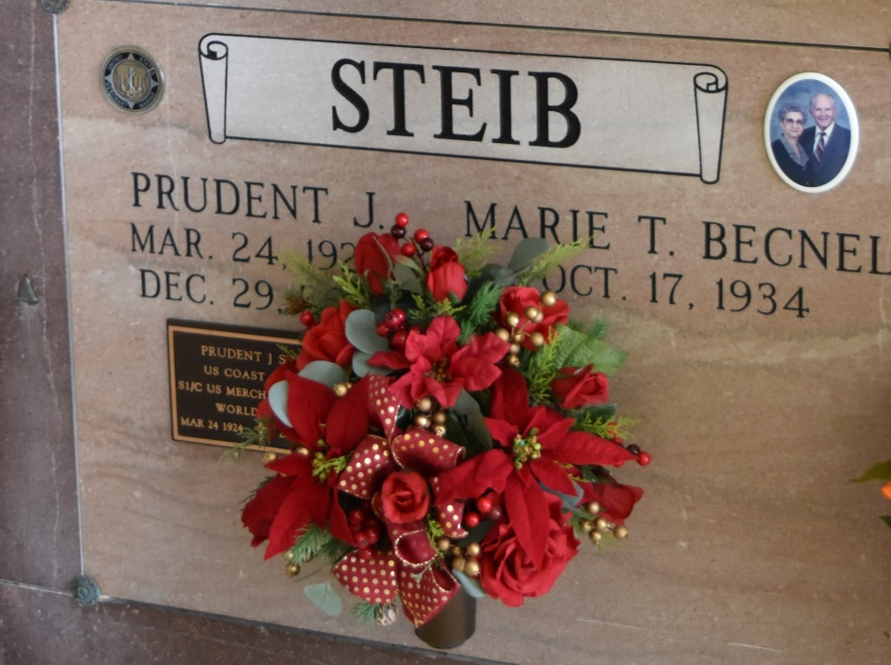

Prudent Joseph Steib, 95, a native and resident of Vacherie, LA passed away on Sunday, December 29, 2019. A visitation will be held on Tuesday, December 31st 2019 at Our Lady of Peace Catholic Church in Vacherie, LA from 8:00 AM until Mass of Christian Burial at 11:00 AM officiated by Fr. John Vu. Interment will follow in the church Mausoleum. Prudent is survived by his wife, Marie Therese Becnel Steib; children, Brad (Kim) Steib, Gail Steib, Denise (Patrick) Waguespack and Craig (Stephanie) Steib; grandchildren, Jeremy (Sarah) Waguespack, Gabrielle (Michael) Prejean, Candice (Scott) Poirrier, Barcley Steib, Brittany Steib, Peyton (Cree) Steib, and Jake Steib; 10 great-grand Children; numerous nieces and nephews. He is preceded in death by his parents, Etienne & Elizabeth Steib; first wife, Rosemary Reulet; siblings, Adolph Steib, Berris Steib, Rene Steib, Etienette Becnel, Josephine Reulet, and Albert Steib. In lieu of flowers, memorial donations can be sent to St James Arc at 29150 Health Unit Street Vacherie, LA. Landry's Funeral Home, Inc. is in charge of arrangements.

Published by TheAdvocate.com from Dec. 29 to Dec. 31, 2019