Raymond Steib

December 4, 1939 – June 15, 2002

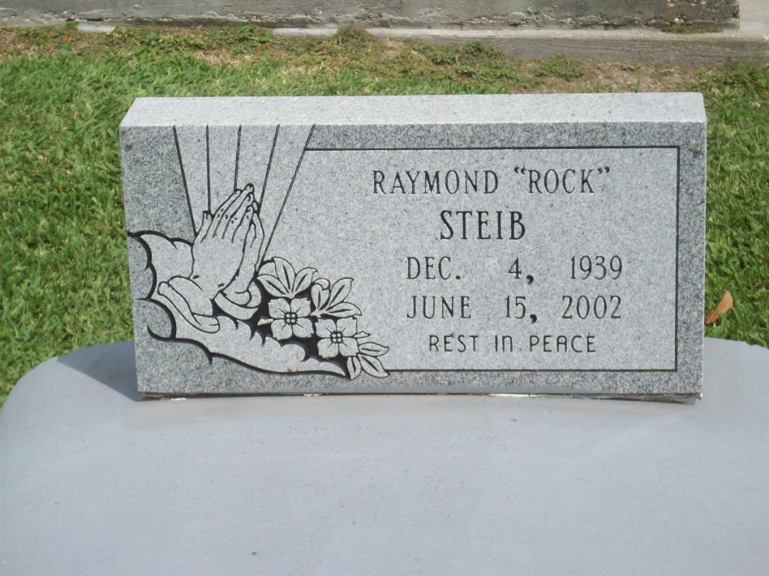

Photo by TMB

Raymond "Rock" Steib, 62, a native of Vacherie and resident of St. James, died June 15. He was the husband of the late Virginia Jackson Steib and father of Kristie and Kellie Sterling and Antoinetta, Fanchonette, Angelo, Antonio and Anquindas Steib. He was the son of Lucille Dumas Steib and the late Clerville Steib Sr. and brother of Rosa Long, Carolyn Gauthier, Geneva Perez and Audrey, Charles, Joseph, John, Wilbert and the late Clerville Steib Jr. He is also survived by four grandchildren. He was a retired welder at Avondale Shipyards.

Unknown source

\*\*\*\*\*

Raymond "Rock" Steib, a retired welder, died Saturday of leukemia at Memorial Medical Center. He was 62. Mr. Steib was born in Vacherie and lived in St. James for the past 42 years. He was retired from Avondale Shipyard. Survivors include three sons, Angelo Steib of Jackson, Miss., Antonio Steib of Houston and Aquindas Steib; four daughters, Fanchonette Steib of Darrow, Kristie Sterling of Atlanta, Kellie Sterling of LaPlace and Antoinetta Steib; his mother, Lucille Dumas Steib; four brothers, Charles, Joseph, John and Wilbert Steib, all of Vacherie; four sisters Audrey Steib of Vacherie, Rose Marie Long of Lutcher, Carolyn Gauthier of Jefferson and Geneva Perez of Harvey; and four grandchildren. A Mass will be said today at 11 a.m. at St. James Catholic Church in St. James. Visitation will begin at 8 a.m. Burial will be in Our Lady of Peace in Vacherie. Demby and Son Funeral Home is in charge of arrangements.

Times-Picayune, The (New Orleans, LA) - Wednesday, June 19, 2002

Contributed by Jane Edson