Regina Marie (Gros) Steib

November 10, 1932 – April 8, 2014

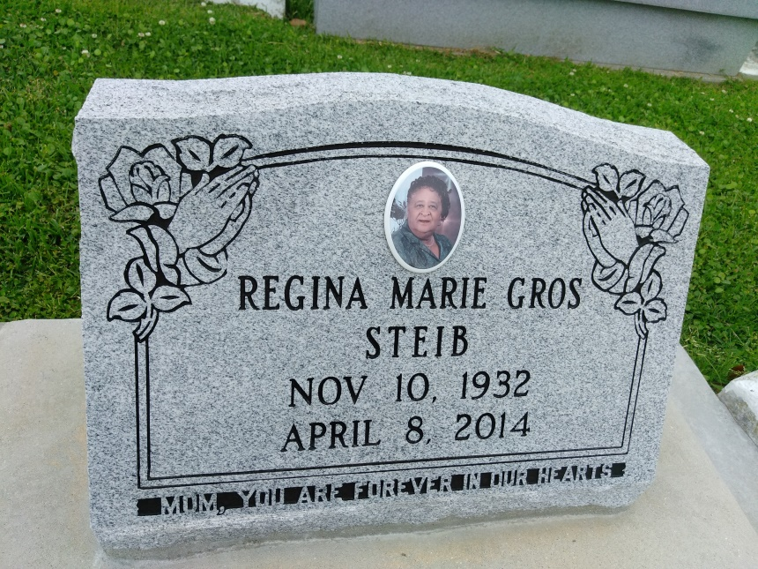

Photo by TMB

Regina Marie Gros Steib passed away Tuesday, April 8, 2014 at the age of 81 years old. Daughter of the late Olympe and Naulest Gros, Sr. Wife of the late Florian Steib. Mother of Sharon (Ellis), Cathy, Gerard, Richard (Vondra), Nicholas (Sharon), Donavon and the late Mark F. Steib. Sister of Raymond (Emelda) Gros, Sr. ( he died Apr. 23, 2014; funeral and burial at OLOP on Wed., Apr. 30th.), Alice (Benoit) Steib, Rose (Teddy) Boudoin, Sr., Daisy (Ridgely) Mitchell, Leboria Burrell, and the late Naulest, Jr. (Jacqueline) Gros, Edmond Gros, Francois Gros, Gladys Narcisse, Ollie Narcisse and Olivia Gros. She was survived by a host of grandchildren, sister-in-laws, brother-in-laws, cousins, nieces, nephews, other relatives and friends.

Funeral services will be held at Our Lady of Peace Catholic Church, 13281 Highway 644, Vacherie, La., on Saturday, April 12, 2014, for 1:00 p.m. Visitation is from 10:00 a.m. until time of service. Father Michael Miceli will be officiating. Interment will be at Our Lady of Peace Catholic Church Cemetery, Vacherie, La. Funeral entrusted to The Baloney Funeral Home, LLC., 1905 W. Airline Highway, Laplace, La., 985-224-8460.  
 Condolences can be expressed at [www.baloneyfuneralhome.com](http://www.baloneyfuneralhome.com).

Times-Picayune, The (New Orleans, LA) - Friday, April 11, 2014

Contributed by Jane Edson