Wilborine (Dumas) Steib

June 25, 1920 – May 18, 2006

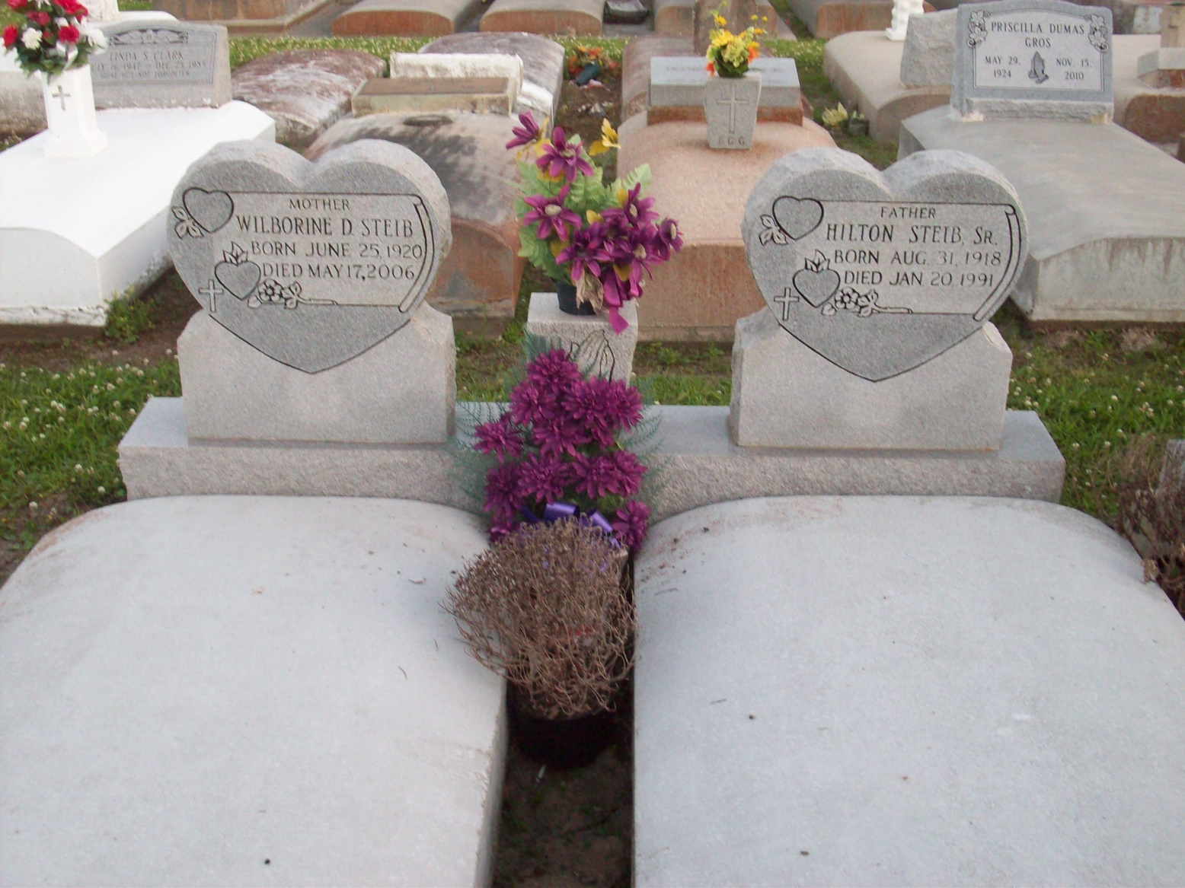

Photo by TMB

Steib, Wilborine Dumas "Teep" A homemaker and a resident and native of Vacherie, she died Thursday, May 18, 2006, at her home at age 85. Visiting at St. James Catholic Church, St. James, on Tuesday, May 23, from 9 a.m. until Mass of Christian Burial at 11 a.m., with the Rev. Louis Oubre, celebrant. Interment in Our Lady of Peace Catholic Cemetery, Vacherie. She is survived by five sons and daughters-in-law, Hamilton and Doris Steib, Vincent and Emily Steib, Raymond and Elaine Steib, Hilton Jr. and Marquelyn Steib, and Pastor Joseph Preston and Dr. Bridget Steib; two daughters and sons-in-law, Rita and Robert Charles and Christine and Marlis Fletcher; three brothers, Leo Paul, Russell and Anthony Dumas; two sisters, Mary Freeman and Celeste James; 17 grandchildren, 20 great-grandchildren and a host of other relatives and friends. She was preceded in death by her husband, Hilton Steib Sr.; parents, Paul and Rose Dumas; four brothers, Whitney, Hayward, Harry and John Dumas; two sisters, Agnes Wooden and Victorine Simon; and a granddaughter, Latricia Steib. Arrangements by Williams & Southall Funeral Home, Napoleonville.

Advocate, The (Baton Rouge, LA) - Monday, May 22, 2006

Contributed by Jane Edson