Marguerite (Webre) Stein

December 1, 1919 - November 28, 1999

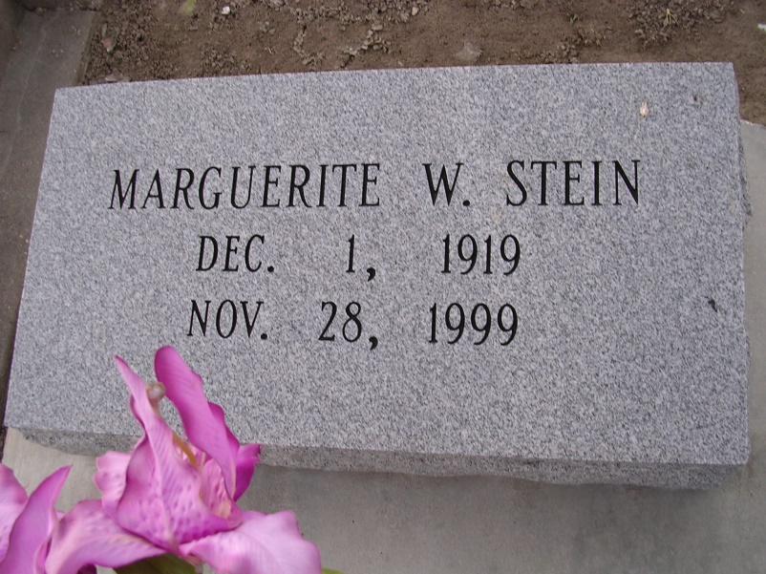

Photo by rrcar

A Mass of Christian burial will be celebrated at 10 a.m. Wednesday at Our Lady of Peace Catholic Church in Vacherie for Marguerite Webre Stein, 79, a native and resident of Vacherie, who died at 9:30 p.m. Nov. 28, 1999. Visitation will be 8 a.m. until funeral time at the church. Burial will be at the church cemetery.  
 She was the mother of Mary Jane Duet, Clare Hymel, Cary, Gerald, Mark and Anthony Stein, all of Vacherie, Huey, Bruno, Ronald, Roland, Stephen, Edmond and Patrick Stein, all of Chackbay, and Drew Stein of North Carolina; and sister of Mary Barre of Westwego, Frances Williams of Seattle, Wash., Agnes Wright of Denton, Texas, and Bessie Rougee and Demase Webre, both of Vacherie. She is also survived by 32 grandchildren and ten great-grandchildren.  
 She was preceded in death by her husband, Leonce J. Stein; parents, John C. and Uraine Webre; daughter, Margaret Stein; and sons, Guy and Claude Stein.

Unknown source