Mark Stein

April 24, 1958 – September 9, 2021

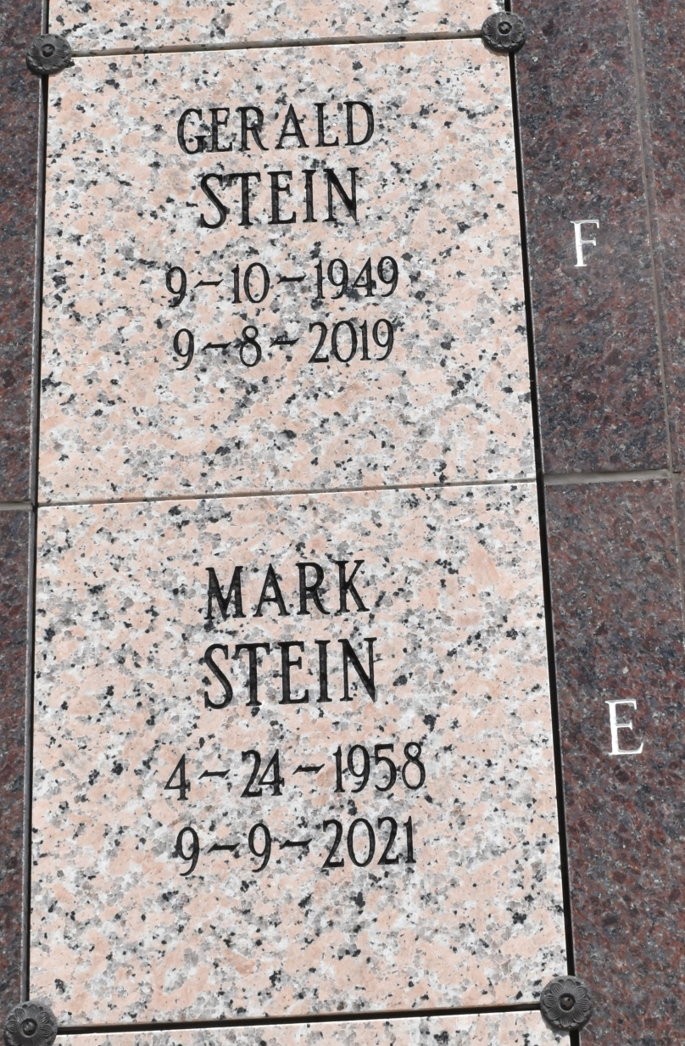

Mark "Ford" Stein, 63, a native and resident of Vacherie, LA passed away on September 9, 2021. Mark's family will hold a Memorial Service for him at a later scheduled date.

Mark is survived by his brothers, Gary, Roland, Stephen, Patrick, Edmond, Drew, and Anthony Stein; sisters, Jane Duet and Claire Hymel. Mark was preceded in death by his brothers, Huey, Ronald, Gerald, Bruno, Guy, and Claude Stein; sister, Margaret Stein; and parents, Leonce and Marguerite Stein. Mark will be missed by all those who knew and loved him.

Online condolences can be given at www.landrysfuneralhome.com  
Landry's Funeral Home, Inc. is in charge of arrangements.

Landry’s Funeral Home

Labadieville, Louisiana