Louis Eddie Stutts
October 1, 1915 – March 30, 2000

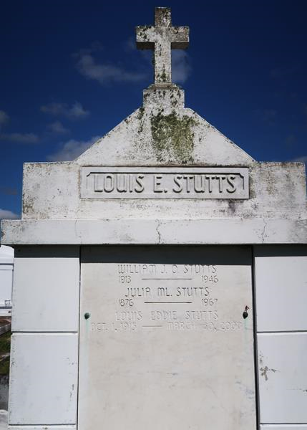

A retired educator, he died Thursday, March 30, 2000, at Thibodaux Regional Medical Center. He was 84 and a native and resident of Vacherie.
Visiting at Our Lady of Peace Catholic Church, Vacherie, from 9 a.m. Monday until Mass of Christian Burial at 11 a.m. Interment in the church cemetery.
Survived by two devoted cousins, Equilla Keller and Nezzie Laurent, both of Vacherie; a nephew, Lawrence Turner; and many other relatives and friends. Williams & Southall Funeral Home, Napoleonville, in charge of arrangements.

Advocate, The (Baton Rouge, LA)
Friday, April 7, 2000

