Allan Joseph Sutherland

December 23, 1958 – December 19, 2017

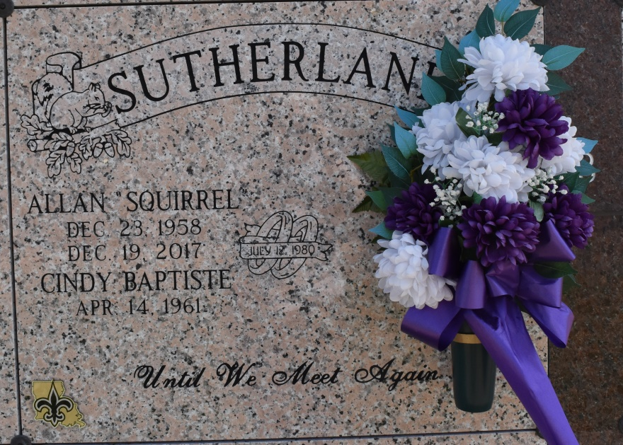

On Tuesday, December 19, 2017, Allan J. Sutherland departed this life to be with the Lord at Memorial Hermann Hospital, Woodland location, in Houston, Texas. His wife was by his side.

Allen, affectionately known as "Squirrel" was a hardworking man. He last worked as a Class A welder for Turner Industries. He trained many how to be proficient at the craft he loved and mastered.

Allan was the son of the late Clinton Sutherland Sr. and Marline F. Sutherland. Husband of Cindy B. Sutherland; two daughters, Lanel and Jamie Sutherland; two granddaughters, Sa'Vya and Solei' Sutherland. Two sisters survive Allan; Zedel (Harry) Oubre and Mathilda Borne; six brothers; Clinton "Butch" Sutherland Jr., Tyrone Sutherland Sr., Eugene (Marilyn) Sutherland Sr., Garry Sutherland, Herman (Charlene) Sutherland and Thaddeus (Laura) Sutherland Sr.; nieces, nephews, in-law, other family members, neighbors, and friends.

Allen was 58 years old. He was a native of St. James, Louisiana and a resident of South Vacherie, Louisiana.

All are invited to attend his home-going celebration on Saturday, December 30, 2017 at Our Lady of Peace Catholic Church, 13281 Highway 644, Vacherie, Louisiana. Reverend Matthew McCaughey, Celebrant. Visitation begins at 9:00 A.M. and Holy Rosary 9:30 A.M. A Mass of Christian Burial will begin at 11:00 A.M. Entombment, Our Lady of Peace Mausoleum. Treasures of Life Funeral Services, LLC has been entrusted with his final care.

Advocate, The (Baton Rouge, LA)

Thursday, December 28, 2017  
Contributed by Jane Edson