Alie Joseph Theriot

October 11, 1915 – January 20, 1993

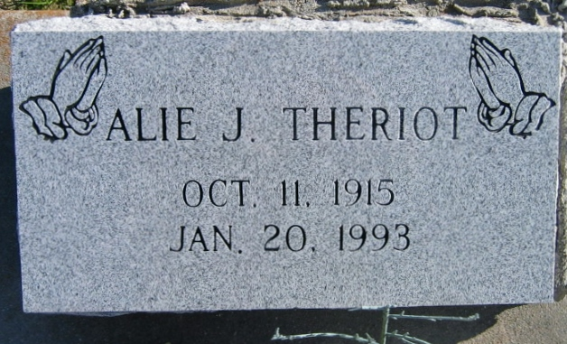

Photo by Bobby

A Mass of Christian burial will be celebrated at 10 a.m. Friday at the St. James Chapel in Choctaw for Alie Joseph “Rat” Theriot, 77, a native of Pierre Part and resident of Choctaw, who died at 4 a.m. Wednesday. Visitation will be from 5:30 to 11 p.m. today and from 8 a.m. until funeral time at the Choctaw Fire Station in Choctaw. Interment will be in the Our Lady of Peace Cemetery in Vacherie.

He was the father of Doris Ann, Joseph, Gustave, Alvin and Edward Theriot and Pauline Bourgeois; brother of Henry and O’Neil Theriot and Theresa and Stella Hebert. He is also survived by 10 grandchildren.

He was preceded in death by his wife, Myrtle Ricourd Theriot; parents, Mr. and Mrs. Henry Theriot Sr.; and three sisters, Lucy Hue, Beulah Rivere and Louise Landry.

Unknown source

Contributed by Roni