Benoit Joseph Tregre

October 13, 1922 – May 1, 2005

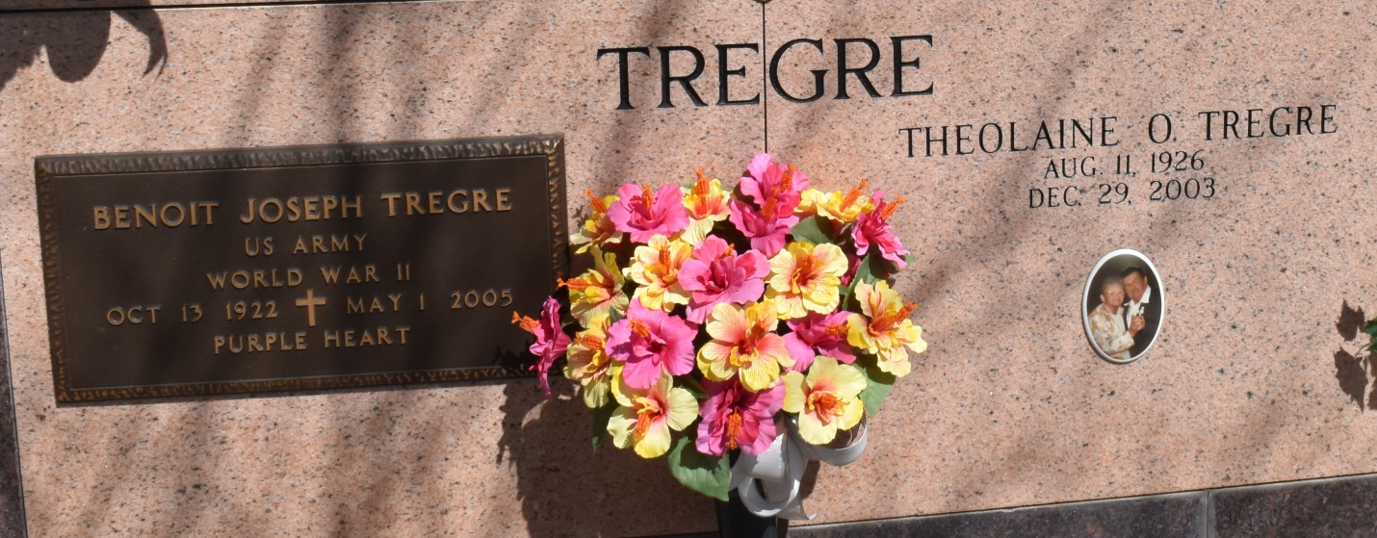

U.S., Veterans' Gravesites, ca.1775-2019

Name: Benoit Joseph Tregre

Death Age: 82

Birth Date: 13 Oct 1922

Death Date: 1 May 2005

Interment Place: Louisiana, USA

Cemetery Address: 13281 Louisiana Hwy 644 Vacherie, La 70090

Cemetery: Our Lady of Peace Church Cemetery

Notes: US Army World War II